CONFIDENTIAL AND PROPRIETARY

Aries Systems Corporation



Product Functional Specification

13.0-33v4

Assign Author

Status: Ready for Management approval

Copyright © 2015, Aries Systems Corporation

This document is the confidential and proprietary property of Aries Systems Corporation. The contents hereof are for use only by recipients specifically identified by Aries, and may not be further disclosed to any other third party. Specifications, designs and drawings contained herein are subject to withdrawal or change by Aries, without notice. Aries shall have no liability resulting from such withdrawal or change. Editorial Manager is a registered trademark and the property of Aries Systems Corporation.

Aries Systems reserves the right to share this specification with other individuals or organizations that have entered into confidentiality agreements with Aries Systems, in which case the specification will be appropriately blinded so that no identifying or proprietary information will be exposed.

Document Summary

Enhancement Name | Assign Author
Specification Number | 13.0-33
Enhancement Type | LWW
Implemented In | 13.1

Document Revision History

Date | Author | Comments
11/02/15 | Di Natale | V0 - Initial draft started
12/21/15 | Di Natale | V1 – Ready for internal review
12/30/15 | Di Natale | V2 – Revisions based on feedback from CW, SU, LC, JS – adds named ‘Un-assign’ link, extends ‘Un-assigned’ link to accepted invitations, adds Author statuses for use on Author Selection Summary page, clarifies connection to Alternate Authors, clarifies that assigned Authors do not trigger Alternate promotions when unassigned, updated ActionManager events, Added Authors to Assign grid to Select Authors – Confirm Selection and Send Letters page
2/09/16 | Di Natale | V3 – Updating based on SM feedback, added new ActionManager event, new statuses on Author Selection Summary page, clarifications around new un-assign link, added test cases
2/12/16 | Di Natale | Ready for Management approval

Specification Approvals
Department | Date | Version | Name
Corporate | 2/17/16 | 4 | LH
Product Mgt.
Engineering | 2/16/16 | 4 | BM
Operations
Customer Service
Aries KG
Sales | 2/16/16 | 4 | RW
Table of Contents

1 Overview 5
1.1 Glossary 5
2 Application Impact 6
2.1 Editor Roles (roleMgrEditor2.asp) 6
2.1.1 New Permissions 6
2.2 admin/eventGrid.asp 7
2.2.1 New Action Manager Events 7
2.3 Author Selection Summary (authorSelectionSummary.aspx) 9
2.3.1 Upload Author List Dropdown Item Info Text 9
2.3.2 Selected Authors Section 10
2.3.3 Alternate Authors Section 12
2.4 Un-invite Authors (confirmAndCustomizeUninvitedAuthors.aspx) 14
2.5 Un-invite E-Mail Confirmation (sendMultipleCustomAuthorInvLetters.asp) 16
2.6 Search for Authors by Name Results page (searchAuthorsByNameAddrResults.asp) 17
2.7 Search for Authors by Personal Classifications Results page [searchAuthorsByPersonalClassResults.asp] 20
2.8 Upload Author List page (uploadAuthorList.aspx) 22
2.9 ‘Author Candidates’ Results page (UploadedAuthorSearchResults.aspx) 23
2.9.1 Author List File import – INVITE field 23
2.10 Select Authors – Confirm Selection and Customize Letters page (confirmAndCustomizeInvitedAuthors.aspx) 24
2.11 Author Invitation Confirmation page (sendMultipleCustomAuthorInvLetters.asp) 27
2.12 Author Main Menu (AuthorMainMenu.aspx) 28
2.13 My Accepted Invitations (authorAcceptedInvitations.asp) 29
3 Database Impact 30
3.1.1 Assigned Author Tracking 30
3.1.2 Author Statistics 31
3.2 DB Content Changes 38
3.3 UDB Impact 38
4 Multi-Lingual Considerations 38
5 Performance Processing Impact 38
5.1 Performance Requirements 38
5.1.1 Data Server 38
5.1.2 Web Server 38
5.1.3 Network 38
5.1.4 Client Machine 38
5.2 Engineering Assessment 38
5.2.1 Engineering Test Results 38
6 Merge Field Impact 39
7 Upgrade Script Impact 39
8 Site Cleanout 39
9 Report Implications 39
9.1 Canned Reports 39
9.1.1 Co-Author Reminder Report 39
9.1.2 Author Revision Status Report 39
9.1.3 Author Revision Reminder Report 39
9.1.4 Automated Author Revision Reminder Report 39
9.1.5 Automated Author Transfer Reminder Report 40
9.1.6 Proposal Pipeline Report 40
9.1.7 Authors Invited – No Response 40
9.1.8 Author Invitation Status Report 40
9.2 General Data Export 40
9.3 Custom Reports 40
9.4 Enterprise Analytics Reporting 41
9.5 Cross-Publication EAR 42
10 Hosting Documentation Impact 42
11 Portal (IJRS, etc.) Impact 42
12 Hosting Administration Impact 42
12.1 Hosting Administration Audit Trail 42
13 Sys Admin Audit Trail 42
14 Import/Export Impact 43
14.1 Transmittal Impact 43
14.2 Aries Export Impact 43
14.3 Aries Import Impact 43
15 Transfer Impact 43
16 Cross-Publication Impact 43
17 Documentation and Training 43
18 Operations’ Considerations 43
18.1 Journal Rename 43
18.2 Journal Redirects 43
19 Utilities 43
20 Audit/Monitor/Diagnostics 43
21 Journal Configuration 44
22 Style Sheet impact 44
23 Deployment Considerations 44
23.1 Associated Revenue Model 44
23.2 Sales and Marketing Rollout Anticipation 44
23.3 Customer Service Rollout Preparation 44
23.4 Release Target 44
24 Future Development 44
25 Mobile Considerations 45
26 Use Cases and Test Scenarios 45
26.1 Regression Test Cases 45
26.2 Specification Test Cases 45
27 Appendix A: Technical Specification 67

Overview
In Editorial Manager a publication can invite Authors to submit manuscripts in order to solicit submissions through the system. Today these solicitations require that the potential Author accept an invitation before the submission process can begin. The sponsoring customer will be using EM to manage a books workflow where Authors are contacted in advance, outside the submission system, agreeing to submit during that communication. For this reason, the option to assign Authors directly has been requested by the sponsoring customer.

Glossary
Author List File (ALF) – An external file to EM which contains a list of Authors and other metadata which can be uploaded into EM in order to allow individuals listed in the file to be selected.

Invited/accepted Author – An Author who were invited and then accepted the invitation to submit a solicited work through Editorial Manager. While this case can exist for Authors in EM today, removing these Authors will trigger new ActionManager events detailed in this specification

Assigned Author – An Author who were directly assigned without invitation to submit a solicited work through Editorial Manager.

Application Impact

Editor Roles (roleMgrEditor2.asp)

New Permissions
- ‘Assign Authors (without Invitation)’ permission is added to the existing Proposals/Commentaries section of RoleManager.

Figure 1: Mocked up Editor RoleManager configurations showing new ‘Assign Authors (without Invitation)’ permission.

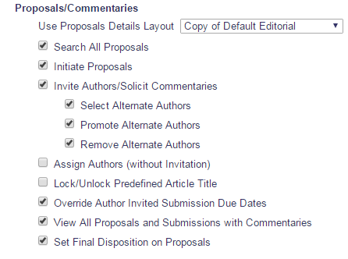

admin/eventGrid.asp

New Action Manager Events
  - Author Assigned (Not Invited) For Proposal
  - If configured for the Author Role, the letter template associated with the event will be the default option on the Select Authors – Confirm Selections and Customize Letters page for each Author being assigned
- Author Assigned (Not Invited) for Commentary
  - If configured for the Author Role, the letter template associated with the event will be the default option on the Select Authors – Confirm Selections and Customize Letters page for each Author being assigned
  - Author Unassigned after Accepting Invitation
    - If configured for the Author Role, the letter template associated with the event will be the default option on the existing Un-Invite Author page for each Author being unassigned
  - Author Unassigned after Assignment
    - If configured for the Author Role, the letter template associated with the event will be the default option on the existing Un-Invite Author page for each Author being unassigned

- Each one of these new events will be used when author is assigned by and editor having the new author assignment permissions.
- As with existing ActionManager events, administrators can select a letter from any letter family other than ‘Ad hoc from Author’, ‘Ad Hoc from Reviewer’ , ‘Ad Hoc from Editor’, ‘Ad Hoc from Publisher’ and ‘Ad Hoc for Proposal’
- At upgrade, no letter is configured for the event for any role. The default value is set to “No Change” at upgrade for existing roles and at creation for new roles
- Document Status for the new events are configurable
- There is no default Alternate Text for Authors for this event

Figure 2: Mocked up ActionManager Role configuration 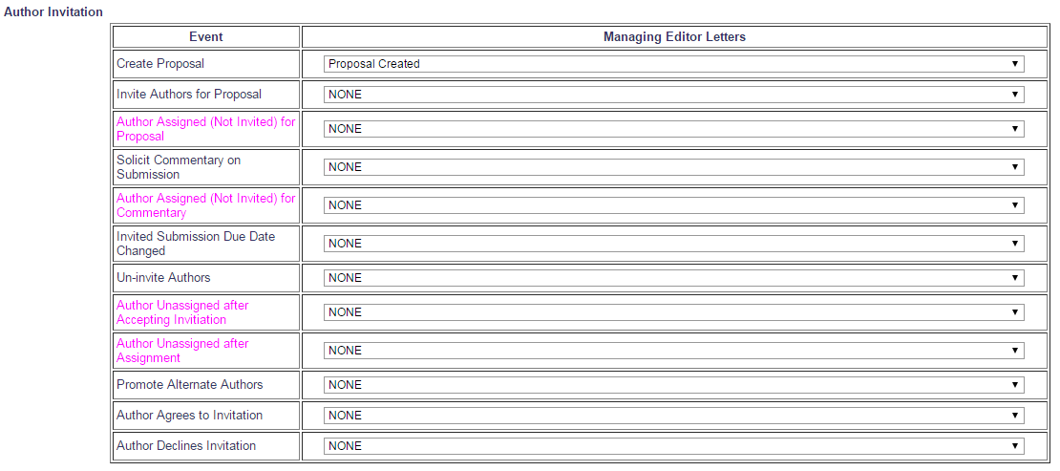

Figure 3: Mocked up ActionManager Document Status configuration page 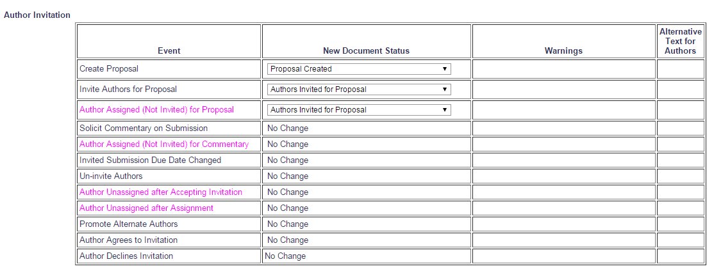

Author Selection Summary (authorSelectionSummary.aspx)

Upload Author List Dropdown Item Info Text

Figure 4: Example of information icon as it appears on the Author Selection Summary page today.

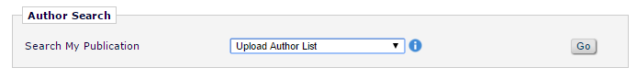

Figure 5: Mocked up partial Author Selection Summary page showing the updated text of the expanded tool tip. Changes are highlighted.

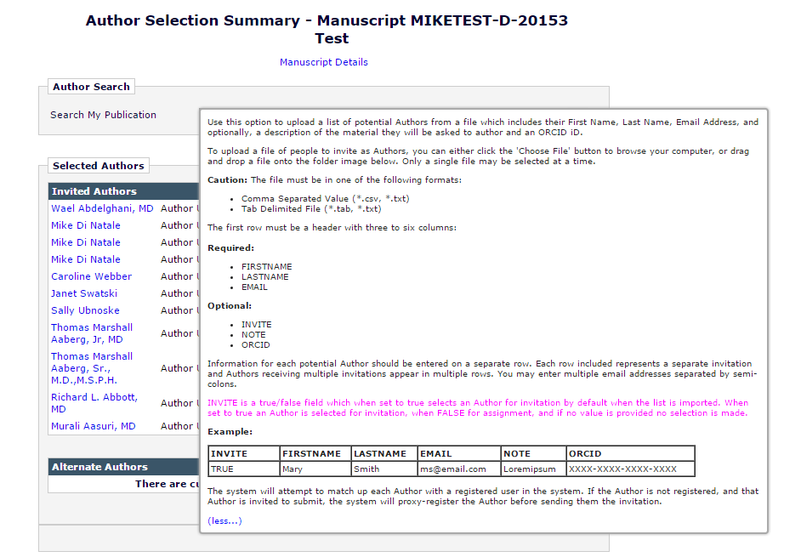

Selected Authors Section

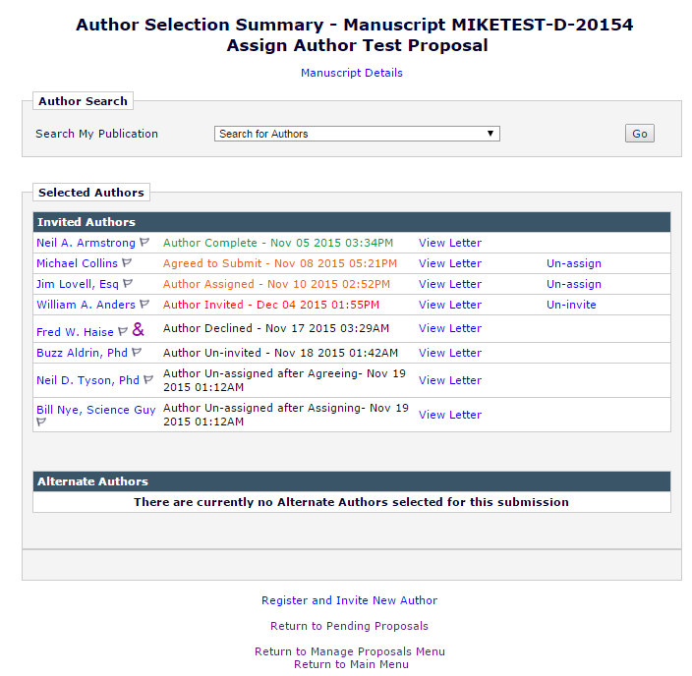

Access to both the ‘Un-invite’ and ‘Un-assign’ links is available to Editors with either the new ‘Assign Authors (without Invitation)’ permission or the existing ‘Invite Authors/Solicit Commentaries.

Editors will be able to use these links to remove Authors regardless of how the Author was solicited or how Editors are permissioned to solicit Authors

Uninvite Link
New in this spec the existing ‘Un-invite’ link is enhanced such that it is available for an Author only prior to accepting an invitation.

The links are suppressed if an Author has been uninvited, unassigned, declined, or has completed the submission process.

The existing ‘Un-invite’ link continues to appear for invited Authors prior to an invitation being accepted

New Un-Assign Link
New is this spec a new ‘Un-assign’ link is available for assigned Authors and authors who accepted an invitation prior to submitting the solicited submission.

The links are suppressed if an Author has been uninvited, unassigned, declined, or has completed the submission process

Using the ‘Un-assign’ link for an invited submission will promote available Alternate Authors as is the case today when using the ‘Un-invite’ link, whereas, removing an Author selected via assig qnment will NOT trigger the promotion of Alternate Authors.

New Grouping of authors.
          - Author Complete
          - Agreed to Submit
          - Author Assigned (NEW)
The status will display with the same color and format as the ‘Agreed to Submit’ status does today for invited submissions where the Author has agreed
- Text is EM orange (#EE6600)
- The status text, as per existing functionality is followed by a hyphen and then a date/time stamp using the site’s configured format
          - Author Invited
          - Author Declined
          - Author Un-invited
          - Author Un-assigned after Agreeing (NEW)
The status will display with the same color and format as the ‘Author Un-invited’ status does today for invited submissions where the Author has agreed
- Text is black
- The status text, as per existing functionality is followed by a hyphen and then a date/time stamp using the site’s configured format
          - Author Un-assigned after Assigning (NEW)
The status will display with the same color and format as the ‘Author Un-invited’ status does today for invited submissions where the Author has agreed
- Text is black
- The status text, as per existing functionality is followed by a hyphen and then a date/time stamp using the site’s configured format

Alternate Authors Section
Will be suppressed for Editors configured with the new ‘Assign Authors (without Invitation)’ permission AND who to do not also have the existing ‘Invite Authors/Solicit Commentaries’ permission enabled when no Alternate Authors have been selected
- An Editor with permission only to assign Authors would only need to see the ‘Alternate Author’ grid if another Editor had selected them
- In existing functionality selected Alternates are visible to Editors without permission to search, remove, or promote them

The grid remains visible to anyone with the existing ‘Invite Authors/Solicit Commentaries’ permission, per existing functionality

Figure 6: Mock-up of the Author Selection Summary page following the implementation of the assign Author functionality. The ‘Alternate Authors’ grid is available because the Editor viewing the page has the ‘Invite Authors/Solicit Commentaries’ permission.

Figure 6b: This mock up is the same as Figure 6, with one notable exception - The ‘Alternate Authors’ grid is NOT available because none have been selected and the Editor viewing the page has only the new ‘Assign Authors (without Invitation)’ permission enabled and not the ‘Invite Authors/Solicit Commentaries’ permission. If another Editor has selected Alternates they will be displayed.
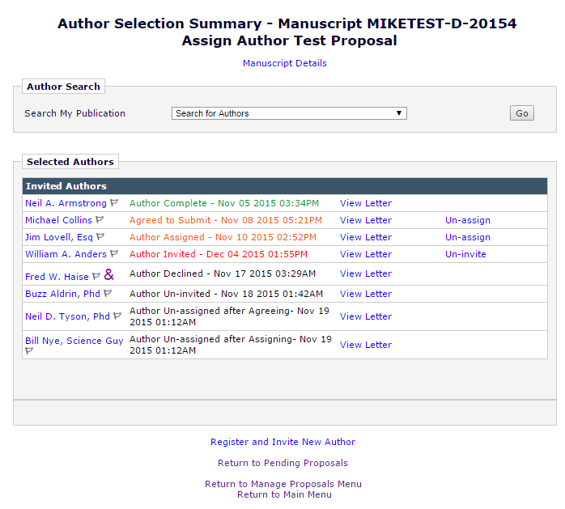

Un-invite Authors (confirmAndCustomizeUninvitedAuthors.aspx)
Reached from the Author Selection Summary page by clicking the ‘Un-invite’ link for a selected Author. The page opens in a pop-up window.

When accessed from the existing ‘Un-invite’ link it appears and functions as it does today under existing functionality.

Figure 7a: When accessed from the new ‘Un-assign’ link the layout is of the page is changed as follows:
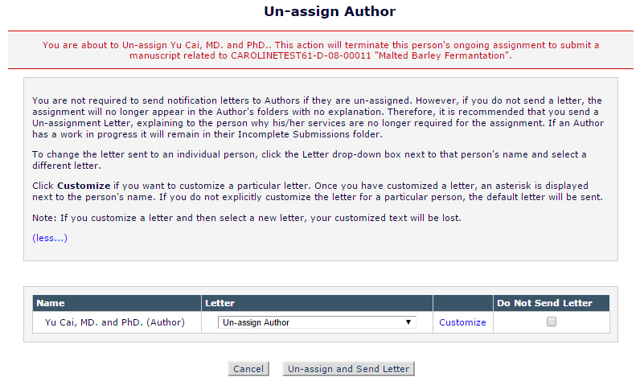

If an alternate author is eligible to be promoted because of the unassignment/univitation, text is added as follows:

Figure 7b:
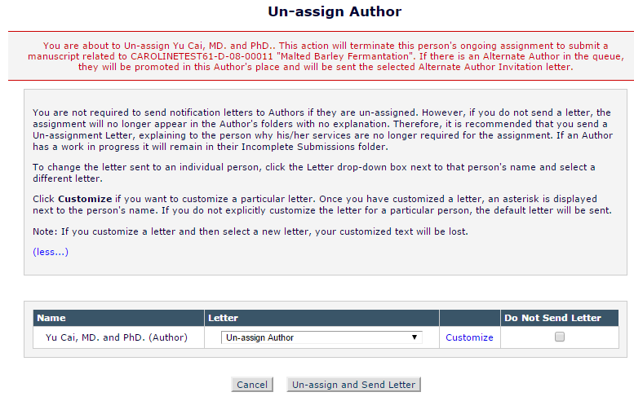

Un-invite E-Mail Confirmation (sendMultipleCustomAuthorInvLetters.asp)
The Un-invite E-Mail Confirmation page is reached by clicking the [Un-invite and Send Letter] button on the Un-invite Author page.

Figure 8: Un-invite E-mail Confirmation page following an Author being uninvited. This confirmation page is identical to what is displayed today when an Author is uninvited. 

Figure 8b: Un-invite E-mail Confirmation page following an Author being uninvited without receiving a notification letter. This confirmation page is identical to what is displayed today when an Author is uninvited.


Figure 8c: Un-invite E-mail Confirmation page mocked up with the new ‘Un-assign’ layout. This confirmation message is displayed when an Author is unassigned and a notification letter is sent.
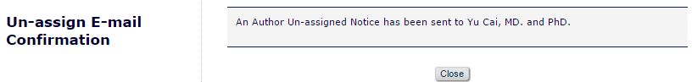

Figure 8d: Un-invite E-mail Confirmation page mocked up with the new ‘Un-assign’ layout. This confirmation message is displayed when an Author is unassigned and no notification is sent.
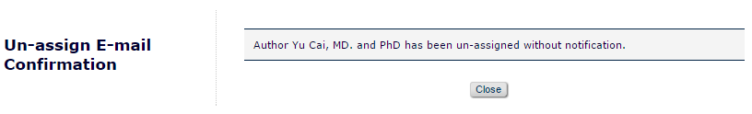

Search for Authors by Name Results page (searchAuthorsByNameAddrResults.asp)
Users access the Search for Authors by Name Results page from the Author Selection Summary page after selecting ‘Search for Authors’ from the search drop down and clicking the [Go] button to arrive at the Search for Authors by Name page [searchAuthorsByNameAddr.asp]. Once a search query is run users will be brought to the Search for Authors by Name Results page to view the results of their search.

Figure 9: Existing Search for Authors by Name Results page.
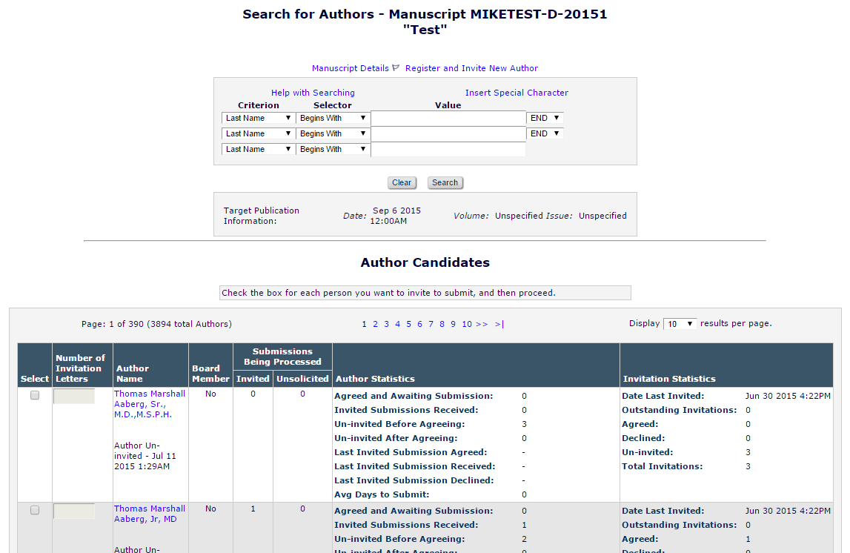

Example: Mock-up of new collapsed instructional text
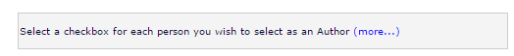

Example: Mock-up of new expanded instructional text
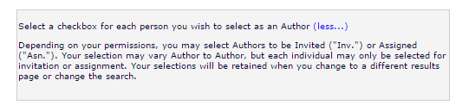

Figure 10: Select column is split into Select As, Inv. and Asn. Also, number of invitations columns retexted to ‘Number of Letters’.
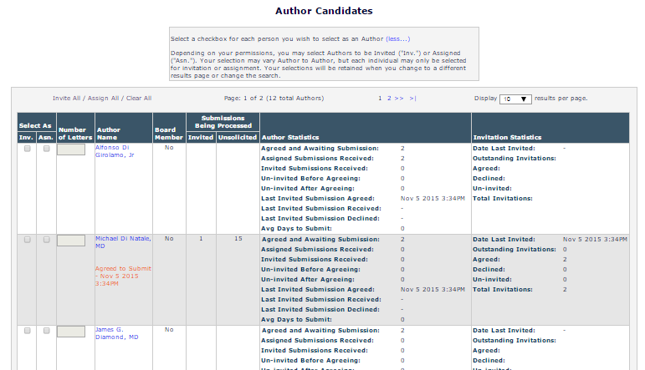

Figure 11: Mock-up of Search for Author by Name Results page as viewed by an Editor with only the ‘Invite Assign/Solicit Commentaries’ permission enabled.
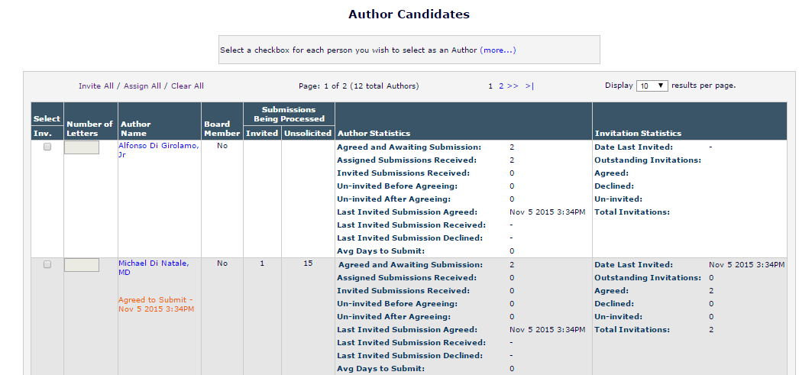

Figure 12: Mock-up of Search for Author by Name Results page as viewed by an Editor with only the ‘Assign Authors (without Invitation)’ permission enabled.
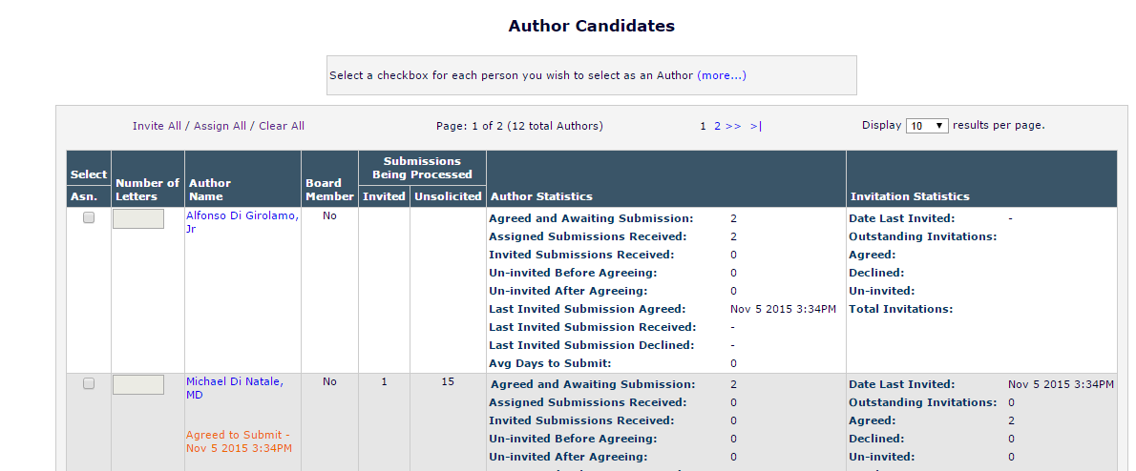

Search for Authors by Personal Classifications Results page [searchAuthorsByPersonalClassResults.asp]

Figure 13: Mock-up of Search for Author by Personal Classifications Results page as viewed by an Editor with both the ‘Invite Assign/Solicit Commentaries’ and ‘Assign Authors (without Invitation)’ permissions enabled.

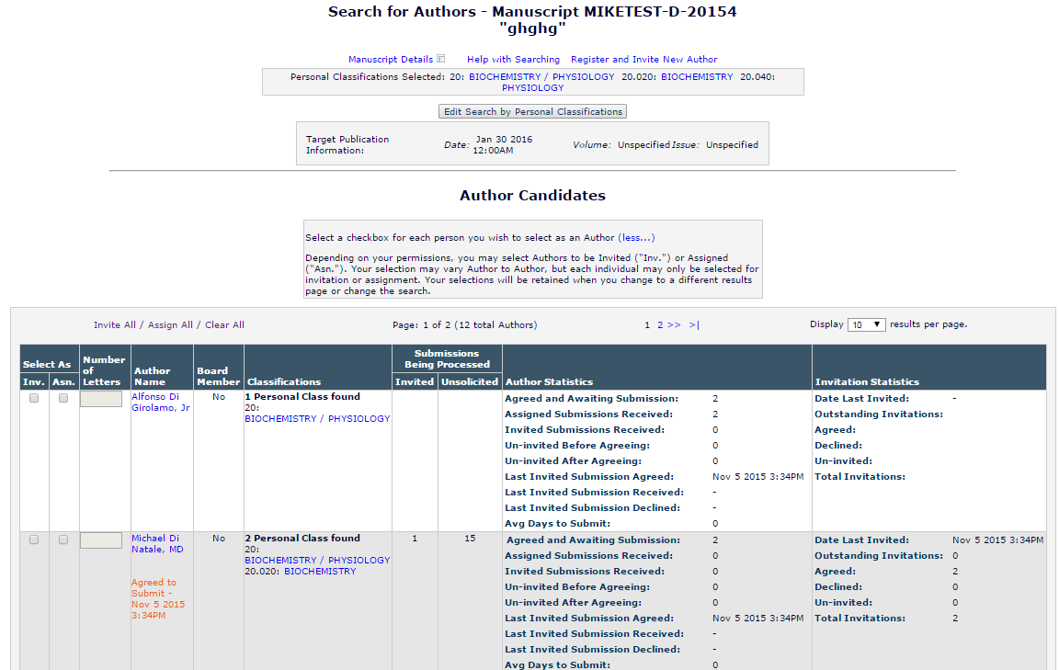

Figure 14: Mock-up of Search for Author by Personal Classifications Results page as viewed by an Editor with only the ‘Invite Assign/Solicit Commentaries’ permission enabled.
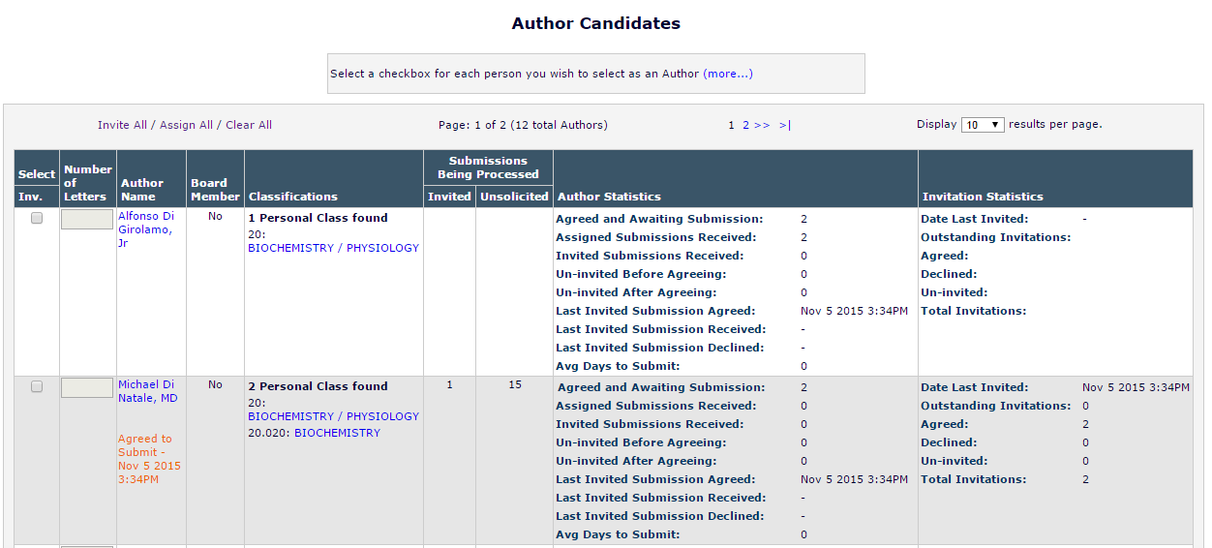

Figure 15: Mock-up of Search for Author by Personal Classifications Results page as viewed by an Editor with only the ‘Assign Authors (without Invitation)’ permission enabled.
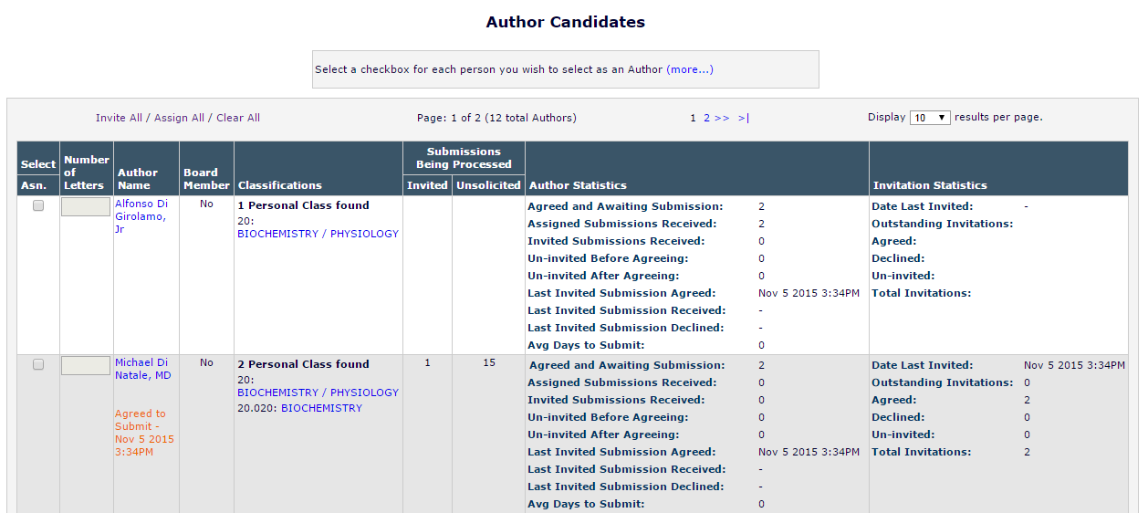

Upload Author List page (uploadAuthorList.aspx)

Figure 16: Mockup of Upload Author List page featuring updated instructional text
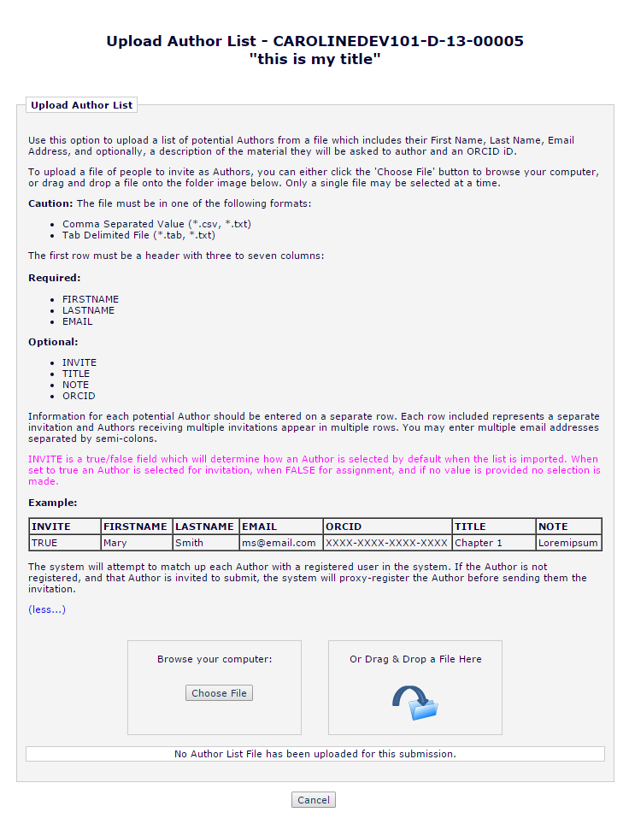

‘Author Candidates’ Results page (UploadedAuthorSearchResults.aspx)

Figure 17: Mocked up ‘Author Candidates’ Results page. In this example the INVITE value for each Author was set to FALSE in the Author List File resulting in the "Asn.” checkbox being enabled initially.

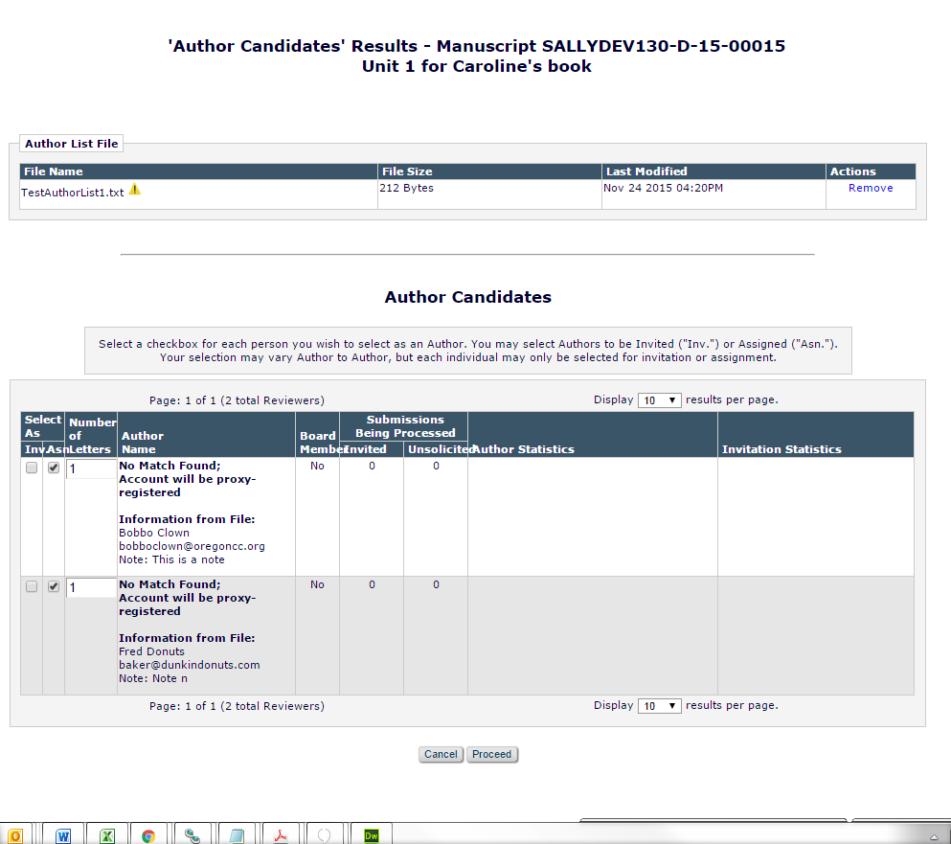

Author List File import – INVITE field
Under the existing functionality, INVITE is a TRUE/FALSE field.
- If INVITE is TRUE the ‘Select’ checkbox for invitation will be selected for the imported record.
- If INVITE is FALSE the ‘Asn’ checkbox will be checked off.
- If INVITE is null/empty, No checkbox is selected.

- The ALF supports multiple entries for the same individual in order to allow Authors to receive multiple invitations or assignments
  - On the ‘Author Candidates’ Results page a record from the ALF which is intended to allow multiple assignments displays as one record with the Number of Letters value populated to match the number of times a user appeared in the ALF
    - Each Author displayed on the ‘Author Candidates’ Results page may only have the Inv. or Asn. checkbox selected
    - When there are multiple records with differing values, the TRUE and FALSE values for INVITE are counted and the value which appears most often for that record is applied, NULL is not considered
      - Example: An Author record in the ALF appears five times, the INVITE value is NULL for two records, TRUE for one and FALSE for two – the record would appear on the ‘Author Candidates’ Results page with the “Asn.” check box selected and five entered as the value for ‘Number of Letters’

Select Authors – Confirm Selection and Customize Letters page (confirmAndCustomizeInvitedAuthors.aspx)

Figure 18: Broken up into two sections – ‘Authors to Invite’ and ‘Authors to Assign’ and ‘Others Notified of Author Invitation’.
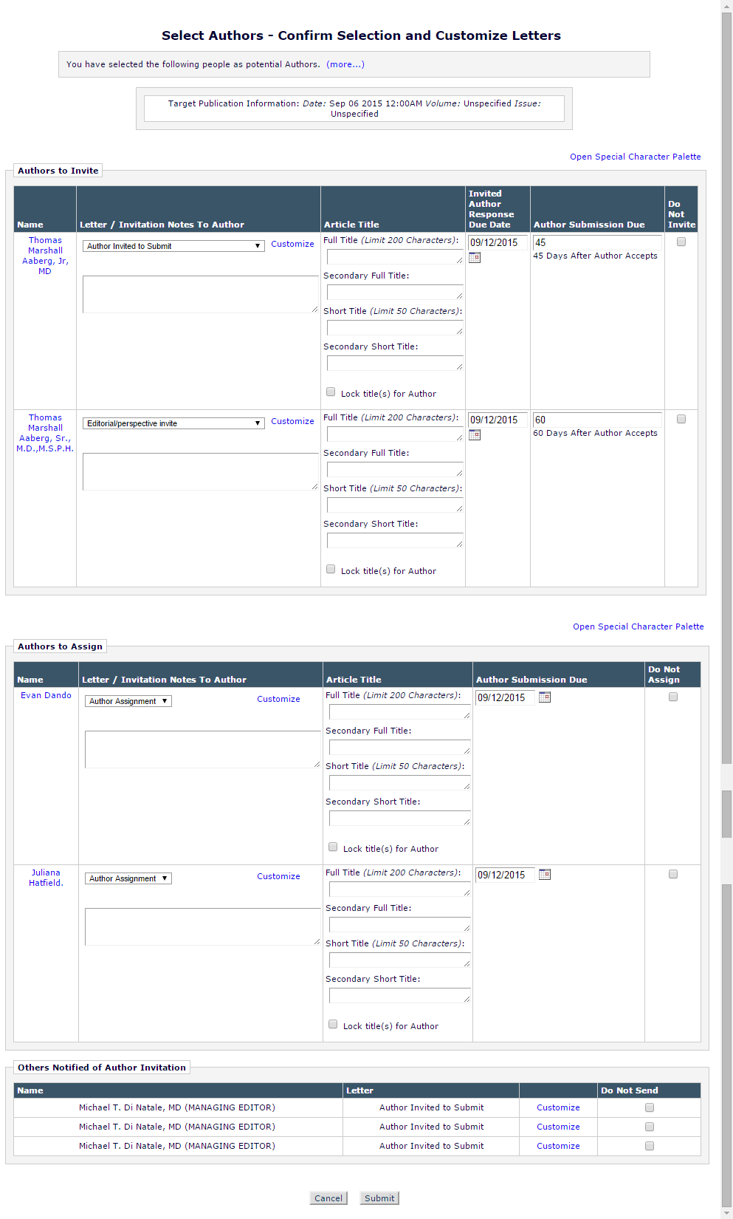

The new ‘Authors to Assign’ grid along with the existing ‘Authors to Invite’ and ‘Others Notified of Author Invitation’ will be suppressed when grids have no content to display on the page.

Figure 19: Mocked up Select Authors – Confirm Selection and Customize Letters page showing the page layout when Authors have been selected for assignment only. The Author Invitation Notes and Pre-Defined Article Title features are also enabled.
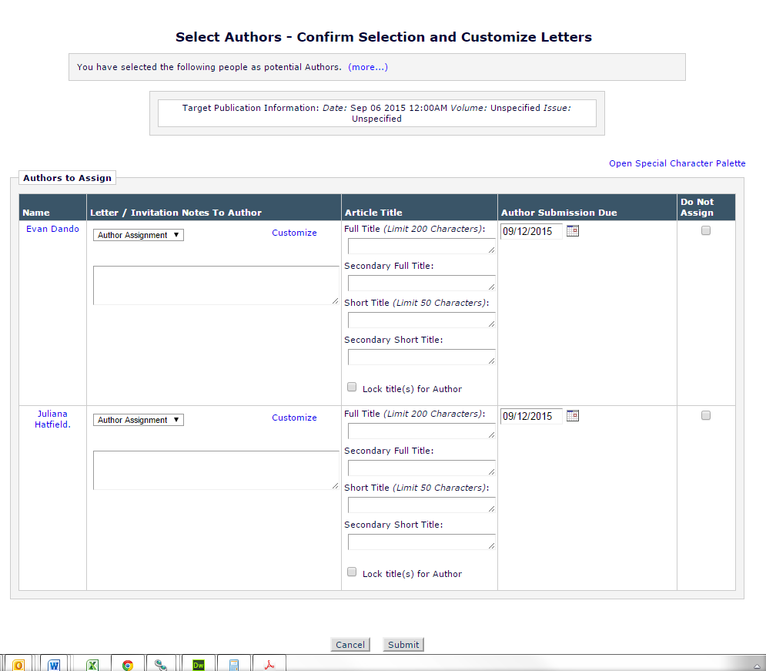

Figure 20: Mocked up Select Authors – Confirm Selection and Customize Letters page showing the page layout when Authors have been selected for invitation only. The Author Invitation Notes and Pre-Defined Article Title features are also enabled.
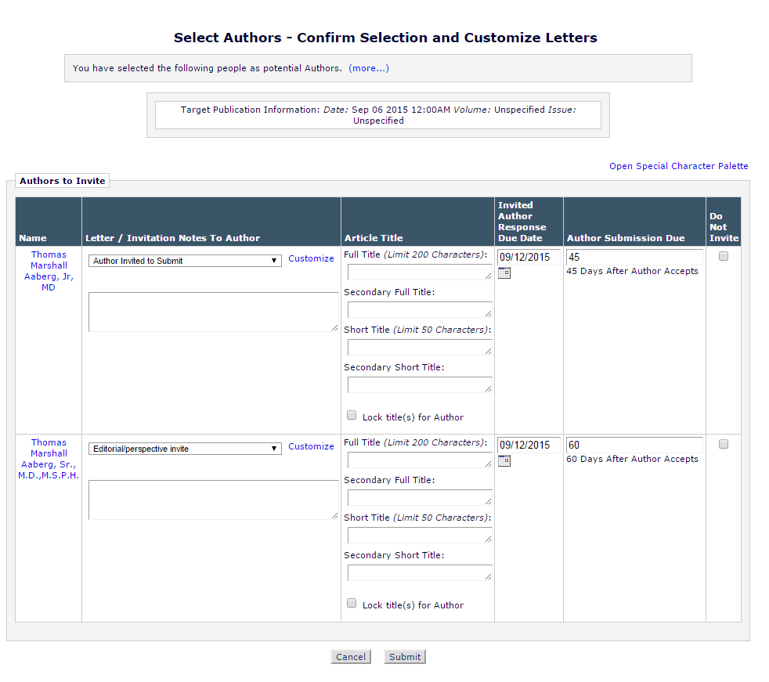

Author Invitation Confirmation page (sendMultipleCustomAuthorInvLetters.asp)

Figure 22: Mockup of enhanced Author Selection Confirmation page now showing Author assignments as well as invitations. Here multiple invitations are sent and the text adjusts by pluralizing Authors. A single assignment is made and this is also reflected in the text.

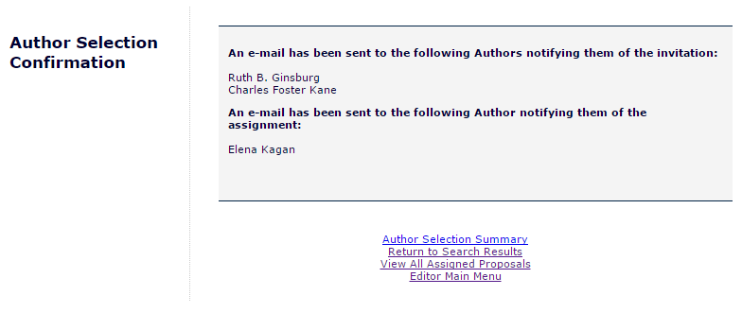

For all users the page is renamed the Author Selection Confirmation page. This change is reflected in the page title and the header placed on the left-hand side of the page.

Author Main Menu (AuthorMainMenu.aspx)

Figure 26: The Author Main Menu will not be visually modified by this specification. Assigned submissions will be directed to the My Accepted Invitations folder as they are provided to the Author.
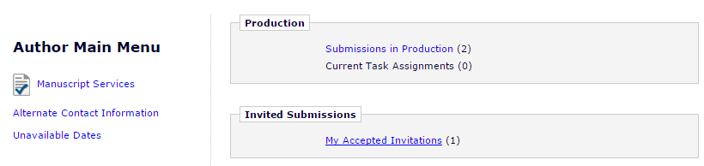

My Accepted Invitations (authorAcceptedInvitations.asp)
The My Accepted Invitations page is accessed from the Author Main Menu by clicking the ‘My Accepted Invitations’ link. The link will be available in the ‘Invited Submissions’ section of the menu when Authors have accepted an invitation or received an assignment

The My Accepted Invitation folder is enhanced to include assigned submissions as well as submissions with accepted invitations

For assignments, link to ‘View Assignment Letter’.

For invitations, link to ‘View Invitation Letter’.

Figure: Mocked up image of the My Accepted Invitations folder. Here an assigned paper (highlighted with a red box) is co-mingled with an accepted invitation. The assignment is noted visually by the inclusion of a ‘View Assignment Letter’ action link.
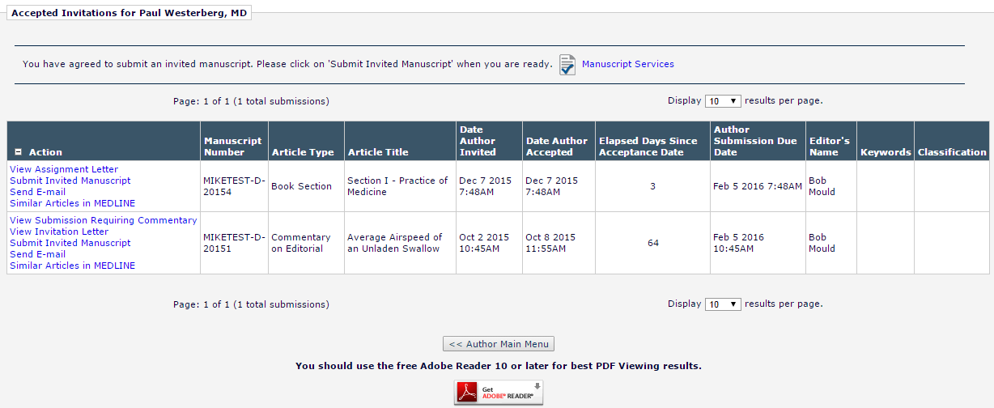

Database Impact

Assigned Author Tracking
Under the existing functionality Author invitations are tracked by Editorial Manager using the Invited Authors Table (INVITED_AUTHORS). This separate table is used because records are not placed into the Author Assignment Table (ROLEAUTH) until an Author begins the submission process. This specification introduces the ability to assign Authors directly in a solicited submission workflow. Assigned Authors, like invited Authors, will need to be recorded separately prior to the creation of a record in the Author Assignment Table.

Engineering will determine the best place to store assigned Author records. It is suggested that the following approach be considered:
- Assigned Author records would be added to the existing INVITED_AUTHORS table
  - New column would be added to the existing table to flag items as invitations or assignments
    - This is critical if the assignments are recorded in an existing table because we will need to be able to report on assignments and separate them from invitations
  - Assignment records would co-exist with invitation related fields in the table and new fields would be added as necessary
    - Note: Reviewer Assignments (ROLEREVU) provides an example of this approach as it tracks Reviewer invitations and assignments
      - Table originally held invitation information only
        - When assignment function (9.0-53) was added, ROLEREVU.ASSIGNED_NOT_INVITED was added to mark records which were assignments
    - Under this scenario the existing table fields would be updated as needed when an Author is assigned
- For the purposes of Author statistics assigned authors would be considered as Authors who had agreed to an invitation
  - A detailed accounting of how this data would be record can be found in Section
- Changes to existing tables or creation of new tables will be fully detailed in the technical spec
  - Users must be able to report on Author assignments as they are currently able to report on Author invitations
  - Users must be able to determine which records were created by assignments and which were created via invitations

Author Statistics
This section assumes Engineering has decided to record incoming Author assignments in the Invited Authors Table, as suggested in Section 2.10.1. This suggestion includes adding a field to the Invited Authors Table to flag records as assignments. If that is not the case this section will be rewritten as needed.

There are two tables used to accumulate Author statistical data. A full detail account of updating these tables must be in the technical spec. Business logic is described below:
- Invited Authors Table [INVITED_AUTHORS]
- Author Invitation Statistics Table [AUTHOR_INVITATION_STATS]

These tables are currently updated when Authors are invited to submit and while the invitation goes through the process of being accepted.

Table 1: The Invited Authors Table is updated as follows when an Author is assigned.
Field Name | Field Location | Action
Unique identifier for this table | INVITED_AUTHORS_ID | ID created for record per existing functionality
Author Accept Date | ACCEPT_DATE | Populated with the date/time that corresponds with the moment of assignment
LetterID for the invitation letter | AUTHOR_INV_LETTER_CORR_HIST_ID | Populated with the Letter ID for the letter sent at assignment to the Author
Date Invited Submission Received | COMPLETE_DATE | Not populated at assignment per existing functionality
Author Completed | COMPLETED | Populated with a value of 0 per existing functionality
Number of days for Author response | DAYS_TO_RESPOND | Not populated when assignment used
Reason for Decline | DECLINE_COMMENTS | Not populated when assignment used
Author Accepted Invitation | WORK_IN_PROGRESS | Populated with a value of 1 indicating the assignment was accepted
Date Author Invited | [INVITATION_DATE] | Populated with the date/time that corresponds with the moment of assignment
Invitation Response Due Date | INVITATION_RESPONSE_DUE_DATE | Not populated when assignment used
Date Last Invitation Reminder Sent | LAST_REMIND_DATE | Not initially populated per existing functionality
Number of Invitation Reminders Sent | REMIND_COUNT | Not initially populated per existing functionality
Author Has Not Responded | HAS_NOT_RESPONDED | This is a bit field which indicates whether an Author has responded to invitation or not. A value of 1 means that the Author responded to invitation and a value of 0 means the Author has not responded to invitation. Assignments are treated as accepted invitations, thus the field is populated with a value of 1 indicating the Author has responded
Author Declined Invitation | DECLINED | Populated with a value of 0
Author Uninvited | UNINVITED | Populated with a value of 0
Date Author Declined Invitation | DECLINE_DATE | Not initially populated
Parent Document ID generating the invitation | DOCUMENTID | Populated with DocID of the parent submission from which the assignment originates
Revision Number | REVISION | Records the revision number of the parent submission at the time of the invitation, when soliciting via Proposals the value is always populated with a value of 0.
Last Update Date | LASTUPDATE | Populated with the date and time of the last update to the record
People ID | PEOPLEID | People ID of the assigned Author
Author Submission Due Date | SUBMISSION_DUE_DATE | Populated with the due date of the solicited submission
Date Author Uninvited | UNINVITE_DATE | Not initially populated per existing functionality
Inviting Editor ID | INVITED_BY | Populated with the people ID of the Editor who invited the Author
Old Inviting Editor ID | OLD_INVITED_BY | Not initially populated per existing functionality
Old People ID | OLD_PEOPLEID | Not initially populated per existing functionality
Last modified DateTime | ROW_LASTMODIFED_TIMESTAMP | Populated with the date and time of the last update to the record
Submissions available to Invited Authors | AUTH_LINKED_DOCS | This is an XML list of submissions. The invited author is given access to the reviewer version of the PDF of these submissions.
ID of the document produced for invitation | CHILD_DOCUMENTID | Not initially populated per existing functionality
Alternate author's rank | ALTERNATE_RANK | NULL value entered
Associated Event Letter ID | EVENT_LETTER_ID | Populated per existing functionality -  This is the ID of a MULTIPLELETTERS entry associated with this solicitation. Tracking assignment letters may require some code changes
Days to submit invited manuscript | DAYS_TO_SUBMIT | Populated used Article Settings per existing functionality
Invitation Notes to Author | INVITED_AUTHOR_NOTES | Populated per existing functionality
Submission Due Date Calculation Type | SUB_DUE_DATE_TYPE | Populated per existing functionality

Table 2: Several fields in the Invited Authors Table are updated when an assigned Author is unassigned via the ‘Un-assign’ link on the Author Selection Summary page. These updates are documented below. All other fields are updated per current coding.
Field Name | Field Location | Action
Author Uninvited | UNINVITED | Populated with a value of 1
Last Update Date | LASTUPDATE | Populated with the date and time of the last update to the record
Date Author Uninvited | UNINVITE_DATE | Populated with the Data/Time at which the Author was uninvited
Last modified DateTime | ROW_LASTMODIFED_TIMESTAMP | Populated with the date and time of the last update to the record

Table 3: Several fields in the Authors Invitation Statistics Table are updated when an Author is assigned a submission. The intention is to treat assigned submissions as accepted invitations when tracking them for statistical purposes.
Field Name | Field | Action
Author Invitation Stats ID | AUTHOR_INVITATION_STATS_ID | ID created for record per existing functionality
People Unique ID | PEOPLE_ID | People ID of the author to which these stats are related
Invited Submissions in Progress | INVITED_SUBMISSIONS_IN_PROGRESS | Counts the number of solicited submissions in process with an Author prior to submission. An assigned submission would increase this number
Invitations Outstanding | INVITATIONS_OUTSTANDING | Not impacted by Author assignments
Total Invitations | TOTAL_INVITATIONS | The total number of invitations sent to an author. It is the sum of Invitations Outstanding, Accepted Invitations, Declined Invitations and Uninvited Before Responding. Since assignments are treated as accepted invitations, this calculation would increase each time an assignment is made
Accepted Invitations | ACCEPTED_INVITATIONS | Increased each time an Author is assigned
Declined Invitations | DECLINED_INVITATIONS | Not impacted by Author assignments
Uninvited Before Responding | UNINVITED_PRIOR_TO_RESPONDING | Not impacted by Author assignments
Uninvited After Accepting | UNINVITED_AFTER_ACCEPTING | Increased when an Author is uninvited following an assignment
Invited Submissions Completed | COMPLETED_INVITATIONS | Increased when an Author submits an assigned submission
Completed On Time | COMPLETED_ON_TIME | Calculation will include assigned submissions
Completed Late | COMPLETED_LATE | Calculation will include assigned submissions
Average Days to Respond | AVERAGE_DAYS_TO_RESPOND | Calculation would not include for records where the associated Author was assigned
Average Days to Complete | AVERAGE_DAYS_TO_COMPLETE | Calculation will include assigned submissions
Average Days Completed Late | AVERAGE_DAYS_COMPLETED_LATE | Calculation will include assigned submissions
Average Reminder Count | AVERAGE_REMINDER_COUNT | Calculation will include assigned submissions
Date Last Accepted | DATE_LAST_ACCEPTED | Will be updated when an Author is assigned
Date Last Declined | DATE_LAST_DECLINED | Not impacted by Author assignments
Date Last Completed | DATE_LAST_COMPLETED | Will be updated when an Author assignment is submitted
Last modified DateTime | ROW_LASTMODIFED_TIMESTAMP | Will be updated when changes made to record are caused by assignments
Date Last Invited | DATE_LAST_INVITED | Will be updated when an Author is assigned and be displayed in the interface as the date an Author was last invited

DB Content Changes

UDB Impact
Considerations: Do new fields need UDB-Only DB Content?

Multi-Lingual Considerations

Performance Processing Impact
Loading of search results pages with the new selection options should not add significant load times to the pages.

Selecting users for assignment should not add significant loading to the sending of letters to Authors.

Adding a check to processing of the Author List File (ALF) to determine which selection option to preselect should not add significant processing times to the handling of the ALF file.

Performance Requirements

Data Server

Web Server

Network

Client Machine

Engineering Assessment

Engineering Test Results

Merge Field Impact

Upgrade Script Impact
If the suggested field for noting that an Author is assigned is added to the INVITED_AUTHORS table, Engineering will determine if a script will be needed to update existing records in INVITED_AUTHORS with a value for the new database field or if users can assume that if the new field is null, the Author was invited.

Site Cleanout

Report Implications
It is suggested that a new bit field be added to INVITED_AUTHORS to indicate that the Author was assigned. If implemented, this field must be designated as “Active” in DBCONTENT, resulting in its appearance in General Data Export and Enterprise Analytics Reporting by default.

A new permission bit field is added to EDITORROLE. This bit field is designated as “Active” in DBCONTENT, resulting in its appearance in General Data Export and Enterprise Analytics Reporting by default.

This section will be updated upon completion of the technical spec so that the final design is represented.

Canned Reports

Co-Author Reminder Report
No change needed. Invitation and assignment data not present in report. Testing must ensure the co-authors tied to Authors who have been assigned appear properly in the report results.

Author Revision Status Report
No change needed. Invitation and assignment data not present in report. Testing must ensure the assigned Authors appear properly in the report results.

Author Revision Reminder Report
No change needed. Invitation and assignment data not present in report. Testing must ensure the assigned Authors appear properly in the report results.

Automated Author Revision Reminder Report
No change needed. Invitation and assignment data not present in report. Testing must ensure the assigned Authors appear properly in the report results.

Automated Author Transfer Reminder Report
No change needed. Invitation and assignment data not present in report. Testing must ensure the assigned Authors appear properly in the report results.

Proposal Pipeline Report
No changes to report coding are necessary if assignment data is captured in the INVITED_AUTHORS table. If existing table is used the Date Author Invited, Date Author Agreed, Date Author Declined and Date Author Invited fields in the result will reflect the values for assignments as detailed by Section 2.11. Assignments would be clearly identifiable in the results set because the Date Author Invited would be NULL while the Date Author Agreed would be populated with the assignment date. Testing must ensure the assigned Authors appear properly in the report results.

Authors Invited – No Response
No change needed. This report is focused on invited submissions where the Author has not yet agreed. Assigned Authors are treated as Authors who have agreed and thus have no place in the results generated by this report.

Author Invitation Status Report
No changes to report coding are necessary if assignment data is captured in the INVITED_AUTHORS table per recommendation. Assigned Authors would be treated as Authors who accepted an invitation to submit and would appear in the report’s results when the established criteria matched as assignment data is stored per Section 2.11.

General Data Export
It is suggested that a new bit field be added to INVITED_AUTHORS to indicate that the Author was assigned. If implemented, this field must be designated as “Active” in DBCONTENT, resulting in its appearance in General Data Export and Enterprise Analytics Reporting by default.

A new permission bit field is added to EDITORROLE. This bit field is designated as “Active” in DBCONTENT, resulting in its appearance in General Data Export.

Two new events are added to EVENT. The new event must be available in General Data Export.

Custom Reports
It is suggested in Section 2.11 that a new bit field be added to INVITED_AUTHORS to indicate that the Author was assigned. If implemented, this field must be added to the Authors & Submissions View (ROLEAUTH_DOC_PEOPLE_ADDR).
- The new bit field is added after the existing Parent Manuscript Number (ROLEAUTH_DOC_PEOPLE_ADDR.PARENT_MS_NUM)
- As with other fields, it is available as a selection criterion and in the report results

Figure: Partial view of the updated ROLEAUTH_DOC_PEOPLE_ADDR view in Custom Reports showing the new field as selectable. Image is cropped to display new option and does not display all available fields.
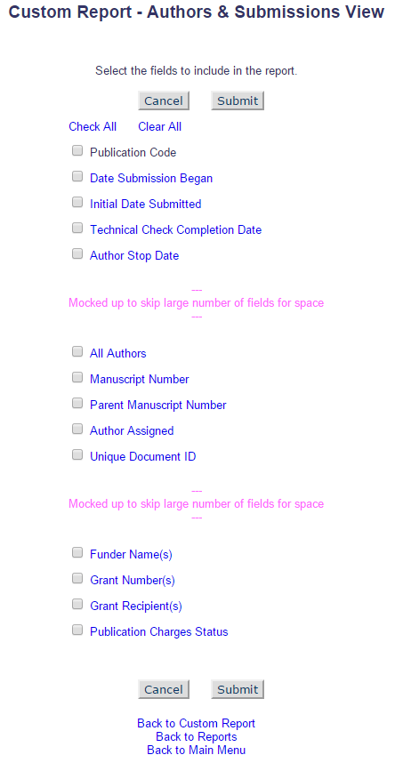

Enterprise Analytics Reporting
It is suggested in Section 2.11 that a new bit field be added to INVITED_AUTHORS to indicate that the Author was assigned. This table is already included in EAR and is available from the Data Sources tab. If the new field is implemented as suggested it must be available in EAR. Additionally, if implemented, this field must be added to the Authors & Submissions View (ROLEAUTH_DOC_PEOPLE_ADDR) where it is available as a data source in EAR.

A new permission bit field is added to EDITORROLE. This bit field is designated as “Active” in DBCONTENT, resulting in its appearance in Enterprise Analytics Reporting as part of the Editor Role Table.

Cross-Publication EAR
It is suggested in Section 2.11 that a new bit field be added to INVITED_AUTHORS to indicate that the Author was assigned, if that table is used to hold Author assignments. If the new field is implemented as suggested it must be added to the Cross-Publication Authors & Submissions View (ROLEAUTH_DOC_PEOPLE_ADDR). This will allow publishers to identify assigned authors across multiple sites.

Hosting Documentation Impact

Portal (IJRS, etc.) Impact
The Authors Results pages show a “Last Invited Submission Agreed” stat. This is a date representing the last time an Author was invited. Under this specification this date is updated when an Author is assigned. This is also visible “Portal-wide” per spec 10.0-62 for sites which share People Information. The impact of the assign functionality updating the value must be considered an impact on the Portal functionality.

Hosting Administration Impact

Hosting Administration Audit Trail
Any changes made to any Hosting Administration code should include invocation of the HA Audit Trail code module to ensure that appropriate data about administration changes are recorded to the HA Audit Trail

Sys Admin Audit Trail
Any changes made to the PolicyManager, RoleManager, ActionManager and AdminManager code should include invocation of the Audit Trail code module to ensure that appropriate data about administration changes are recorded to the Audit Trail.

Import/Export Impact
Should consist of elements/data 1) that would need to be added to the generic Aries Export schema/XML and/or 2) available for Aries import and added to the “Select Fields for Import” page and Aries Import schema and script.

Transmittal Impact

Aries Export Impact

Aries Import Impact

Transfer Impact

Cross-Publication Impact
Anything not covered in the reporting section (i.e. journal acronym change, cross-pub login, consideration for additional use cases, etc.)

Documentation and Training

Operations’ Considerations

Journal Rename

Journal Redirects

Utilities
Consider any or all of the following with Engineering consultation:
- UDB Utility
- Upgrader
- IJRS Sync Tool
- Deleter
- Cloner
- Migrator
- Translation Utility

Audit/Monitor/Diagnostics
Used when going out to a 3rd party system to detect if the system is up. Add to an existing “Tembria dashboard”; indicate who should get e-mail notices if 3rd party goes down.

Journal Configuration
The ability to Assign Authors is available to Editors who have been configured with the new RoleManager permission, ‘Assign Authors (Commentaries/Proposals’. Once the permission is enabled Editors will be able to select an assignment checkbox when searching for Authors by name or classification matches.

Three related ActionManager events must be configured with letter templates in order to ensure that proper notifications are sent to Authors as they are assigned and unassigned. These events are:
- ‘Author Assigned (Not Invited) for Proposal’
  - Triggered when an Author is assigned via a Proposal
- ‘Author Assigned (Not Invited) for Commentary’
  - Triggered when an Author is assigned via Solicit Commentary
- ‘Author Unassigned’
  - Triggered when an Author is unassigned

No configuration is necessary to select Authors for assignment when selecting Authors using an uploaded Author List File (ALF). The assignment option will also be available to Editors who have uploaded and ALF.

Style Sheet impact

Deployment Considerations

Associated Revenue Model

Sales and Marketing Rollout Anticipation

Customer Service Rollout Preparation

Release Target
This specification is developed for 13.1

Future Development
Future development may require additional changes to the AUTHOR_INVITATION_STATS table in order to further separate out tracking of assignments versus invitations.

Mobile Considerations
Functional considerations for smartphones and tablets (if applicable)

Use Cases and Test Scenarios
Test cases will be added prior to management approval.

Regression Test Cases

Specification Test Cases
- Confirm new ‘Assign Authors (without Invitation)’ permission is available in RoleManager for Editors
  - As an administrator log into EM
  - Go to System Administrator Functions and select RoleManager
  - Click the ‘Editor Role’ link and then click the [Add] button to open a new RoleManager configuration page
  - Scroll to the Proposals and Commentaries section and confirm that the new ‘Assign Authors (without Invitation)’ is present, displayed immediately before the ‘Lock/Unlock Predefined Article Title’ permission
  - Confirm that the permission can be selected and unselected
  - Confirm that the permission can be selected and unselected independently of the existing ‘Invite Authors/Solicit Commentaries’ permission
  - Confirm that the permission remains selected once saved as selected
  - Confirm that the permission remains deselected once saved as deselected
- Confirm that the four new ActionManager events implemented in this specification are present when configuring a user role, that initially no letter is selected each new event, and that for each a letter can be selected
  - As an administrator log into EM
  - Go to System Administrator Functions and select ActionManager
    - Confirm that the following new events are present in the Author Invitation section when configuring user roles:
      - ‘Author Assigned (Not Invited) for Proposal’
        - Displayed following ‘Invite Authors for Proposal’
      - ‘Author Assigned (Not Invited) for Commentary’
        - Displayed following ‘Solicit Commentary on Submission’
      - ‘Author Unassigned after Accepting Invitation’
        - Displayed following ‘Un-invite Authors’
      - ‘Author Unassigned after Assignment’
        - Displayed following ‘Author Unassigned after Accepting Invitation’
    - Confirm that initially no letters are selected for these events
    - Confirm that users can select letters for the events
    - Confirm that once selected the selections can be saved
- Confirm that new ActionManager events are present when configuring Document Status, confirm that initially no new document status is selected
  - As an administrator log into EM
  - Go to System Administrator Functions and select ActionManager
    - Confirm that the following new events are present in the Author Invitation section when configuring Document Status:
      - ‘Author Assigned (Not Invited) for Proposal’
        - Displayed following ‘Invite Authors for Proposal’
      - ‘Author Assigned (Not Invited) for Commentary’
        - Displayed following ‘Solicit Commentary on Submission’
      - ‘Author Unassigned after Accepting Invitation’
        - Displayed following ‘Un-invite Authors’
      - ‘Author Unassigned after Assignment’
        - Displayed following ‘Author Unassigned after Accepting Invitation’
    - Confirm that initially no letters are selected for these events
  - Confirm that ‘Author Assigned (Not Invited) for Proposal’ can have a status selected
    - Confirm that once selected the selection can be saved and changed
  - Confirm that the remaining three events cannot
- Confirm the ‘Upload Author List’ tool tip on the Author Selection Summary page is updated with the new text presented in this specification
  - Log into a test site using an Editor who has either the new ‘Assign Authors (without Invitation)’ permission, the ‘Invite Authors/Solicit Commentaries’ permission or both
  - Go to the Author Selection Summary page either via the Solicit Commentary Action Link for a submission or the Invite Authors Action Link available for a Proposal
    - On the Author Selection Summary page select ‘Upload Author List’ from the Search My Publication drop-own menu
    - Confirm that the blue and white “i” icon appears to the right of the menu when the ‘Upload Author List’ option is selected
    - Confirm that hovering over the icon produces an expandable tool tip
      - Expand the tool tip and confirm that the following text is displayed (as indicated by Section 2.3):

Use this option to upload a list of potential Authors from a file which includes their First Name, Last Name, Email Address, and optionally, a description of the material they will be asked to author and an ORCID iD.

To upload a file of people to invite as Authors, you can either click the 'Choose File' button to browse your computer, or drag and drop a file onto the folder image below. Only a single file may be selected at a time.

Caution: The file must be in one of the following formats:
- Comma Separated Value (*.csv, *.txt)
- Tab Delimited File (*.tab, *.txt)

The first row must be a header with three to seven columns:
Required:
- FIRSTNAME
- LASTNAME
- EMAIL
Optional:
- INVITE
- TITLE
- NOTE
- ORCID

Information for each potential Author should be entered on a separate row. Each row included represents a separate invitation and Authors receiving multiple invitations appear in multiple rows. You may enter multiple email addresses separated by semi-colons.

INVITE is a true/false field which will determine how an Author is selected by default when the list is imported. When set to TRUE an Author is selected for invitation, when FALSE for assignment, and if no value is provided no selection is made.

Example:
INVITE | FIRSTNAME | LASTNAME | EMAIL | ORCID | TITLE | NOTE
TRUE | Mary | Smith | ms@email.com | XXXX-XXXX-XXXX-XXXX | Chapter 1 | Loremipsum

The system will attempt to match up each Author with a registered user in the system. If the Author is not registered and that Author is invited to submit, the system will proxy-register the Author before sending them the invitation.

- Confirm enhanced instructions display when choosing to search for Authors from the Author Selection Summary page
  - Log into the test site as an Editor with the new ‘Assign Authors (without Invitation)’ permission, the ‘Invite Authors/Solicit Commentaries’ permission or both enabled
  - Go to the Author Selection Summary page either via the Solicit Commentary Action Link for a submission or the Invite Authors Action Link available for a Proposal
    - On the Author Selection Summary page select ‘Search for Authors’ from the Search My Publication drop-down menu in order to test the Search for Authors by Name Results page
    - Click the [Go] button
    - You’ll now be able to search for an Author, enter criteria which will produce results
    - When the ‘Author Candidates’ grid appear confirm that the updates instructions are displayed:
      - The new text is inserted into the existing grey box
      - The new instructional text is expandable,
      - The text initially appears as collapsed when search results are loaded
        - The collapsed text includes a portion of the full text followed by a “(more…)” link
        - The collapsed text reads: “Select a checkbox fir each person you wish to select as an Author”
        - When the “(more…)” link is clicked the grey box is expanded to show the full text
          - When expanded the “(more...)” link becomes a “(less…)” link
          - Additional text is displayed: “Depending on your permissions, you may select Authors to be Invited ("Inv.") or Assigned ("Asn."). Your selection may vary Author to Author, but each individual may only be selected for invitation or assignment. Your selections will be retained when you change to a different results page or change the search.”
          - When the “(less…)” link is clicked the grey box returns to its initial state and the additional text is hidden
  - Repeat the above steps but instead select ‘Search by Personal Classifications’ from the search drop-down menu in order to test the Search for Authors by Personal Classifications Results page
  - Confirm the instructions appear on both pages regardless of whether an Editor has the new ‘Assign Authors (without Invitation)’ permission, the ‘Invite Authors/Solicit Commentaries’ permission or both enabled
- Confirm the UI enhancements to the Author search results pages (Search for Authors by Personal Classifications Results page and Search for Authors by Name Results page) when the ‘Assign Authors (without Invitation)’ permission and the ‘Invite Authors/Solicit Commentaries’ permissions are enabled
  - Log into the test site as an Editor with both the new ‘Assign Authors (without Invitation)’ permission and the ‘Invite Authors/Solicit Commentaries’ permission enabled
    - Go to the Author Selection Summary page either via the Solicit Commentary Action Link for a submission or the Invite Authors Action Link available for a Proposal
      - On the Author Selection Summary page select ‘Search for Authors’ from the Search My Publication drop-down menu in order to test the Search for Authors by Name Results page
      - Click the [Go] button
      - You’ll now be able to search for an Author, enter criteria which will produce results
    - The ‘Author Candidates’ grid is enhanced
      - Confirm that the former ‘Number of Invitation Letters’ column header is relabelled ‘Number of Letters’
      - Confirm that the ‘Select’ column is relabelled ‘Select As’
        - Confirm that the cell below is split and displaying a column labelled “Inv.” on the left and a column labelled “Asn.” on the right
        - Confirm selection labels are formatted as headers with white, bold text against an EM blue background
        - Confirm that a checkbox appears centered in each column for each user in the search result
        - Confirm that only one of the check boxes can be selected for each user record in the result
        - Confirm that selecting one option for a user will unselect the other, if it is already selected
        - Confirm that different checkbox selection between separate user accounts in the result set is allowed
    - Repeat the above steps but instead select ‘Search by Personal Classifications’ from the search drop-down menu in order to test the Search for Authors by Personal Classifications Results page
- Confirm the UI enhancements to the Author search results pages (Search for Authors by Personal Classifications Results page and Search for Authors by Name Results page) when the ‘Assign Authors (without Invitation)’ permission is enabled
  - Log into the test site as an Editor with only the new ‘Assign Authors (without Invitation)’ permission enabled
    - Go to the Author Selection Summary page either via the Solicit Commentary Action Link for a submission or the Invite Authors Action Link available for a Proposal
      - On the Author Selection Summary page select ‘Search for Authors’ from the Search My Publication drop-down menu in order to test the Search for Authors by Name Results page
      - Click the [Go] button
      - You’ll now be able to search for an Author, enter criteria which will produce results
    - The ‘Author Candidates’ grid is enhanced
      - Confirm that the former ‘Number of Invitation Letters’ column header is relabelled ‘Number of Letters’
      - Confirm that the selection column is labelled ‘Select’
        - Confirm that the cell below ‘Select’ in the grid heads a single column labelled “Asn.”
          - Confirm “Asn.” label is formatted as a header with white, bold text against an EM blue background
        - Confirm that a checkbox appears centered in the column for each user in the search result
        - Confirm that the check box can be selected and unselected
    - Repeat the above steps but instead select ‘Search by Personal Classifications’ from the search drop-down menu in order to test the Search for Authors by Personal Classifications Results page
- Confirm the UI enhancements to the Author search results pages (Search for Authors by Personal Classifications Results page and Search for Authors by Name Results page) when the ‘Invite Authors/Solicit Commentaries’ permission is enabled
  - Log into the test site as an Editor with only the ‘Invite Authors/Solicit Commentaries’ permission enabled
    - Go to the Author Selection Summary page either via the Solicit Commentary Action Link for a submission or the Invite Authors Action Link available for a Proposal
      - On the Author Selection Summary page select ‘Search for Authors’ from the Search My Publication drop-down menu in order to test the Search for Authors by Name Results page
      - Click the [Go] button
      - You’ll now be able to search for an Author, enter criteria which will produce results
    - The ‘Author Candidates’ grid is enhanced
      - Confirm that the former ‘Number of Invitation Letters’ column header is relabelled ‘Number of Letters’
      - Confirm that the selection column is labelled ‘Select’
        - Confirm that the cell below ‘Select’ in the grid heads a single column labelled “Inv.”
          - Confirm “Inv.” label is formatted as a header with white, bold text against an EM blue background
        - Confirm that a checkbox appears centered in the column for each user in the search result
        - Confirm that the check box can be selected and unselected
    - Repeat the above steps but instead select ‘Search by Personal Classifications’ from the search drop-down menu in order to test the Search for Authors by Personal Classifications Results page
- Confirm that assignment of Authors takes place when Authors are selected using the new assignment option when inviting Author using a Proposal
  - Log into the test site as an Editor with the new ‘Assign Authors (without Invitation)’ permission enabled and the ‘Invite Authors/Solicit Commentaries’ permission not enabled
    - Go to the Author Selection Summary page either via the Invite Authors Action Link available for a Proposal
      - On the Author Selection Summary page select ‘Search for Authors’ from the Search My Publication drop-down menu in order to test the Search for Authors by Name Results page
      - Click the [Go] button
      - You’ll now be able to search for an Author, enter criteria which will produce results
    - In the ‘Author Candidates’ grid
      - Select a “Asn.” check box for an Author and then click the [Proceed] button
      - You will be brought to the ‘Select Author – Confirm Selection and Customize Letter page
        - Confirm that the default letter selected for the Author’s notification is the letter associated with the ‘Author Assigned (Not Invited) for Proposal’ ActionManager event
        - Proceed
          - Confirm that the Author Invitation Confirmation page is displayed
          - Confirmed that the Author Invitation Confirmation page title and header are updated to “Author Selection Confirmation”

        - Confirm the letter was sent to the Author
    - Log in as the Author

    - Repeat the above steps but instead select ‘Search by Personal Classifications’ from the search drop-down menu in order to test the Search for Authors by Personal Classifications Results page

- Confirm that Author Selection Summary page is updated such that the ‘Selected Authors’ grid reflects the new assignment and unassignment statuses which have been added
  - Log into the test site as an Editor with both the new ‘Assign Authors (without Invitation)’ permission and the ‘Invite Authors/Solicit Commentaries’ permission enabled
    - Go to the Author Selection Summary page either via the Solicit Commentary Action Link for a submission or the Invite Authors Action Link available for a Proposal
      - For the test paper invite and assign a mix of Authors, these Authors will be made to accept, decline, not response, be invited, and unassigned in order to test the Author invitation statuses and availability of links on the page
      - Within the ‘Selected Author’ grid:
        - When an Author has submitted their invited submission, confirm:
          - The Author name is displayed as a link to their People Information page
          - A status of ‘Author Complete’ is displayed followed by the date of submission in green text
          - A ‘View Letter’ link is displayed which links to the invitation letter sent to the Author
        - When an Author has submitted their assigned submission, confirm:
          - The Author name is displayed as a link to their People Information page
          - A status of ‘Author Complete’ is displayed followed by the date of submission in green text
          - A ‘View Letter’ link is displayed which links to the assignment letter sent to the Author
        - When an Author has agreed to an submit after receiving an invitation, confirm:
          - The Author name is displayed as a link to their People Information page
          - A status of ‘Agreed to Submit’ is displayed followed by the date the Author agreed in orange
          - A ‘View Letter’ link is displayed which links to the invitation letter sent to the Author
          - An ‘Un-assign’ link is available to uninvite the Author
        - When an Author has been assigned, confirm:
          - The Author name is displayed as a link to their People Information page
          - A status of ‘Author Assigned’ is displayed followed by the date the Author was assigned in orange
          - A ‘View Letter’ link is displayed which links to the assignment letter sent to the Author
          - An ‘Un-assign’ link is available to uninvite the Author
        - When an Author has been invited, confirm:
          - The Author name is displayed as a link to their People Information page
          - A status of ‘Author Invited’ is displayed followed by the Date of the invitation in red
          - A ‘View Letter’ link is displayed which links to the invitation letter sent to the Author
          - An ‘Un-invite’ link is available to uninvite the Author
        - When an Author has declined, confirm:
          - The Author name is displayed as a link to their People Information page
          - A status of ‘Author Declined’ is displayed followed by the date of the decline in black
          - A ‘View Letter’ link is displayed which links to the invitation letter sent to the Author
        - When an Author has been uninvited, confirm:
          - The Author name is displayed as a link to their People Information page
          - A status of ‘Author Un-invited’ is displayed followed by the uninvited date in black
          - A ‘View Letter’ link is displayed which links to the invitation letter sent to the Author
        - When an Author has been unassigned after agreeing to an invitation, confirm:
          - The Author name is displayed as a link to their People Information page
          - A status of ‘Author Un-assigned after Agreeing’ is displayed followed by the unassigned date in black
          - A ‘View Letter’ link is displayed which links to the invitation letter sent to the Author
        - When an Author has been unassigned after receiving an assignment, confirm:
          - The Author name is displayed as a link to their People Information page
          - A status of ‘Author Un-assigned after Assigning’ is displayed followed by the unassigned date in black
          - A ‘View Letter’ link is displayed which links to the assignment letter sent to the Author
      - Confirm that the Selected Authors grid sorts on the Author status using the following order of statuses, followed by date:
          - Author Complete
          - Agreed to Submit
          - Author Assigned
          - Author Invited
          - Author Declined
          - Author Un-invited
          - Author Un-assigned after Agreeing
          - Author Un-assigned after Assigning
- Confirm Editors have access to both Un-invite and Un-assign links on the Author Selection Summary page when configured with only the ‘Assign Authors (without Invitation)’ permission OR the ‘Invite Authors/Solicit Commentaries’ permission
  - Editors can uninvite and unassign Authors with either permission the ‘Assign Authors (without Invitation)’ permission OR the ‘Invite Authors/Solicit Commentaries’ permission enabled
  - Setup a test parent submission with an invited Author, an invited Author who has accepted, and an assigned Author
    - Go to the Author Selection Summary page for the test page while logged in as an editor with Log into the test site as an Editor with the ‘Invite Authors/Solicit Commentaries’ permission enabled and the ‘Assign Authors (without Invitation)’ permission NOT enabled
      - Confirm the user can see the ‘Un-invite’ link for the invited author and the ‘Un-assign’ link for the invitation where the Author agreed, as well as for the direct assignment
      - Confirm that the links are functional and direct Editors to the Un-invite Author page
    - Go to the Author Selection Summary page for the test page while logged in as an editor with Log into the test site as an Editor with the ‘Assign Authors (without Invitation)’ permission enabled and the ‘Invite Authors/Solicit Commentaries’ permission NOT enabled
      - Confirm the user can see the ‘Un-invite’ link for the invited author and the ‘Un-assign’ link for the invitation where the Author agreed, as well as for the direct assignment
      - Confirm that the links are functional and direct Editors to the Un-invite Author page
- Confirm Alternate Authors grid on Author Selection Summary page is displayed properly
  - Log into the test site as an Editor with both the new ‘Assign Authors (without Invitation)’ permission and the ‘Invite Authors/Solicit Commentaries’ permission enabled
    - Go to the Author Selection Summary page either via the Solicit Commentary Action Link for a submission or the Invite Authors Action Link available for a Proposal
      - Use a test paper where no Alternate Authors have been selected
      - Confirm that the ‘Alternate Authors’ grid is displayed despite no Alternates being selected
      - Select Alternate Authors for the test paper and confirm grid is still displayed
  - Log into the test site as an Editor with the ‘Invite Authors/Solicit Commentaries’ permission enabled and the new ‘Assign Authors (without Invitation)’ permission NOT enabled
    - Go to the Author Selection Summary page either via the Solicit Commentary Action Link for a submission or the Invite Authors Action Link available for a Proposal
      - Use a test paper where no Alternate Authors have been selected
      - Confirm that the ‘Alternate Authors’ grid is displayed despite no Alternates being selected
      - Select Alternate Authors for the test paper and confirm grid is still displayed
  - Log into the test site as an Editor with the new ‘Assign Authors (without Invitation)’ permission enabled and the ‘Invite Authors/Solicit Commentaries’ permission NOT enabled
    - Go to the Author Selection Summary page either via the Solicit Commentary Action Link for a submission or the Invite Authors Action Link available for a Proposal
      - Use a test paper where no Alternate Authors have been selected
      - Confirm that the ‘Alternate Authors’ grid is NOT displayed
      - Select Alternate Authors for the test paper and confirm grid is only then displayed
- Confirm the Un-invite Author page is working as expected
  - When an Editors has either the ‘Assign Authors (without Invitation)’ permission OR the ‘Invite Authors/Solicit Commentaries’ permission enabled they will be able to uninvite and unassign editors from the Author Selection Summary page using links available in the ‘Selected Authors’ grid
    - Repeat items b.i, b.ii, and b.iii with Editor configured:
      - With the ‘Assign Authors (without Invitation)’ permission AND the ‘Invite Authors/Solicit Commentaries’ permission enabled
      - With the ‘Assign Authors (without Invitation)’ permission enabled AND the ‘Invite Authors/Solicit Commentaries’ permission NOT enabled
      - With the ‘Assign Authors (without Invitation)’ permission NOT enabled AND the ‘Invite Authors/Solicit Commentaries’ permission enabled
  - Setup a test parent submission with an invited Author, an invited Author who has accepted, and an assigned Author as well as three alternate Authors configured to automatically be promoted
    - Go to the Author Selection Summary page for the test paper
      - Click the ‘Un-invite’ link for the invited Author
        - Confirm the Editor is brought to the Un-invite Author page
        - Confirm that the existing page is used and unaltered in layout
        - Confirm that the default letter in the Letter selection drop-down menu is the letter associated with the ‘Un-invite Authors’ ActionManager event
        - Confirm that once the Author is uninvited an alternate is promoted
        - Confirm that the Editor is brought to the existing Un-invite E-Mail Confirmation page
        - Confirm Author remains listed on the Author Selection Summary page in the ‘Selected Authors’ grid with a status of ‘Author Un-invited’
    - Go to the Author Selection Summary page for the test paper
      - Click the ‘Un-assign’ link for the invitation accepted by the Author
        - Confirm the Editor is brought to the Un-assign Author page
        - Confirm the page header and title is labeled “Un-assign Author”
        - Confirm the page uses the following warning text:
          - You are about to Un-assign AUTHOR FULL NAME. This action will terminate this person’s ongoing assignment to submit a manuscript related to the PARENT SUBMISSION MANUSCRIPT NUMBER “PARENT SUBMISSION FULL TITLE”. If there is an Alternate Author in the queue, they will be promoted in this Author’s place and will be sent the selected Alternate Author Invitation Letter.
            - Where AUTHOR FULL NAME is the First, Middle, and Last name of an Author followed by their degree
            - Where PARENT SUBMISSION MANUSCRIPT NUMBER is the manuscript number of the associated parent submission
            - Where PARENT SUBMISSION FULL TITLE is the manuscript number of the associated parent submission
          - Repeat when no Alternate Authors are available and confirm warning text reads :
          - You are about to Un-assign AUTHOR FULL NAME. This action will terminate this person’s assignment to submit a manuscript related to the PARENT SUBMISSION MANUSCRIPT NUMBER “PARENT SUBMISSION FULL TITLE”.
            - Where AUTHOR FULL NAME is the First, Middle, and Last name of an Author followed by their degree
            - Where PARENT SUBMISSION MANUSCRIPT NUMBER is the manuscript number of the associated parent submission
            - Where PARENT SUBMISSION FULL TITLE is the manuscript number of the associated parent submission
        - Confirm that the default letter in the Letter selection drop-down menu is the letter associated with the ‘Author Unassigned after Accepting Invitation’ ActionManager event
        - Confirm the [Un-assign and Send Letter] button appears at the bottom of the page
        - Confirm that the Editor is brought the Un-assign E-Mail Confirmation page
        - Confirm that once the Author is uninvited an alternate is promoted
        - Confirm Author remains listed on the Author Selection Summary page in the ‘Selected Authors’ grid with a status of ‘Author Un-assigned after Agreeing’
    - Go to the Author Selection Summary page for the test paper
      - Click the ‘Un-assign’ link for the assigned Author
        - Confirm the Editor is brought to the Un-assign Author page
        - Confirm the page header and title is labeled “Un-assign Author”
        - Confirm the page uses the following warning text:
          - You are about to Un-assign AUTHOR FULL NAME. This action will terminate this person’s ongoing assignment to submit a manuscript related to the PARENT SUBMISSION MANUSCRIPT NUMBER “PARENT SUBMISSION FULL TITLE”. If there is an Alternate Author in the queue, they will be promoted in this Author’s place and will be sent the selected Alternate Author Invitation Letter.
            - Where AUTHOR FULL NAME is the First, Middle, and Last name of an Author followed by their degree
            - Where PARENT SUBMISSION MANUSCRIPT NUMBER is the manuscript number of the associated parent submission
            - Where PARENT SUBMISSION FULL TITLE is the manuscript number of the associated parent submission
          - Repeat when no Alternate Authors are available and confirm warning text reads :
          - You are about to Un-assign AUTHOR FULL NAME. This action will terminate this person’s assignment to submit a manuscript related to the PARENT SUBMISSION MANUSCRIPT NUMBER “PARENT SUBMISSION FULL TITLE”.
            - Where AUTHOR FULL NAME is the First, Middle, and Last name of an Author followed by their degree
            - Where PARENT SUBMISSION MANUSCRIPT NUMBER is the manuscript number of the associated parent submission
            - Where PARENT SUBMISSION FULL TITLE is the manuscript number of the associated parent submission
        - Confirm that the default letter in the Letter selection drop-down menu is the letter associated with the ‘Author Unassigned after Assignment’ ActionManager event
        - Confirm the [Un-assign and Send Letter] button appears at the bottom of the page
        - Confirm that the Editor is brought the Un-assign E-Mail Confirmation page after confirming
        - Confirm that once the Author is uninvited an NO alternate is promoted, alternates are not promoted when unassigning Authors selected via assignment
        - Confirm Author remains listed on the Author Selection Summary page in the ‘Selected Authors’ grid with a status of ‘Author Un-assigned after Assigning’
- Confirm enhanced Un-Invite/Unassign Email Confirmation page displays correct layout when accessed
  - The Un-invite E-Mail Confirmation page is enhanced to offer separate layouts depending on whether a user was uninvited or unassigned
  - Confirm that when the confirmation page is accessed when an invited Author is uninvited that:
    - The layout for the ‘Un-invited’ workflow is identical to the existing page
    - The confirmation message on the page varies depending on whether or not the Author was sent a notification, per existing functionality
      - If a letter is sent the confirmation message reads ““An Author Un-invited Notice has been sent to AUTHOR FULL NAME”
      - When an Author is NOT sent a notification letter the updated text reads: “Author [AUTHOR FULL NAME] has been un-invited without notification”
      - [AUTHOR FULL NAME] is populated with the Author’s First, Middle, and Last names followed by their degree
  - Confirm that when an invited Author who has accepted or an assigned Author is unassigned that:
    - The confirmation page header and title reads “Un-assign Email Confirmation”
    - The confirmation message on the page varies depending on whether or not the Author was sent a notification, per existing functionality
      - When an Author is sent a notification letter the updated text reads: “An Author Un-assigned Notice has been sent to AUTHOR FULL NAME”
      - When an Author is NOT sent a notification letter the updated text reads: “Author [AUTHOR FULL NAME] has been un-assigned without notification”
      - [AUTHOR FULL NAME] is populated with the Author’s First, Middle, and Last names followed by their degree
- Confirm enhanced Upload Author List Process processing assignments correctly
  - Create a valid Author List File for testing the selection of Authors using the ‘Upload Author File’ option on the Author Selection Summary page
    - Within the file select a mix of Authors for invitations and assignments using the logic described in Section 2.9.1, a value of TRUE selects an Author for invitation and a value of FALSE selects them for assignment – all other values result in no selection
  - Log into a test site using an Editor
    - Repeat steps with an Editor using three different configurations:
      - Editor has ‘Assign Authors (without Invitation)’ permission enabled and the ‘Invite Authors/Solicit Commentaries’ permission disabled
      - Editor has ‘Assign Authors (without Invitation)’ permission disabled and the ‘Invite Authors/Solicit Commentaries’ permission enabled
      - Editor has both ‘Assign Authors (without Invitation)’ and the ‘Invite Authors/Solicit Commentaries’ permissions enabled
    - Note: Results should be the same regardless of these configurations
  - Go to the Author Selection Summary page either via the Solicit Commentary Action Link for a submission or the Invite Authors Action Link available for a Proposal
    - On the Author Selection Summary page select ‘Upload Author List’ from the Search My Publication drop-own menu and click the [Go] button
    - You will be on the Upload Author List page
      - Confirm that the instructions on the page have been updated:
        - The instructions are located within the ‘Upload Author List’ grid placed on the page
        - The instructional text is expandable/collapsible using more/less links
        - The collapsed version of the text is unchanged by this specification
        - The expanded text is updated as follows:
Use this option to upload a list of potential Authors from a file which includes their First Name, Last Name, Email Address, and optionally, a description of the material they will be asked to author and an ORCID iD.

To upload a file of people to invite as Authors, you can either click the 'Choose File' button to browse your computer, or drag and drop a file onto the folder image below. Only a single file may be selected at a time.

Caution: The file must be in one of the following formats:
- Comma Separated Value (*.csv, *.txt)
- Tab Delimited File (*.tab, *.txt)

The first row must be a header with three to seven columns:
Required:
- FIRSTNAME
- LASTNAME
- EMAIL
Optional:
- INVITE
- TITLE
- NOTE
- ORCID

Information for each potential Author should be entered on a separate row. Each row included represents a separate invitation and Authors receiving multiple invitations appear in multiple rows. You may enter multiple email addresses separated by semi-colons.

INVITE is a true/false field which will determine how an Author is selected by default when the list is imported. When set to TRUE an Author is selected for invitation, when FALSE for assignment, and if no value is provided no selection is made.

Example:
INVITE | FIRSTNAME | LASTNAME | EMAIL | ORCID | TITLE | NOTE
TRUE | Mary | Smith | ms@email.com | XXXX-XXXX-XXXX-XXXX | Chapter 1 | Loremipsum

The system will attempt to match up each Author with a registered user in the system. If the Author is not registered and that Author is invited to submit, the system will proxy-register the Author before sending them the invitation.

    - Upload you Author List File (ALF)
      - Confirm that the overlay preview displays all the data contained in the file
      - Then proceed
    - You will be directed to the ‘Author Candidates’ Results page
      - All of the Authors contained in the file will be displayed
      - Regardless of the Editor’s permissions the ability to select authors for invitation or assignment will be present
    - The ‘Author Candidates’ grid is enhanced
      - Confirm that the former ‘Number of Invitation Letters’ column header is relabelled ‘Number of Letters’
      - Confirm that the ‘Select’ column is relabelled ‘Select As’
        - Confirm that the cell below is split and displaying a column labelled “Inv.” on the left and a column labelled “Asn.” on the right
        - Confirm selection labels are formatted as headers with white, bold text against an EM blue background
        - Confirm that a checkbox appears centered in each column for each user in the search result
        - Confirm that only one of the check boxes can be selected for each user record in the result
        - Confirm that selecting one option for a user will unselect the other, if it is already selected
        - Confirm that different checkbox selection between separate user accounts in the result set is allowed
    - Confirm that Authors listed in the ALF with INVITE column values of TRUE are selected for invitation
    - Confirm that Authors listed in the ALF with INVITE column values of FALSE are selected for assignment
    - Confirm that Authors listed in the ALF with INVITE column values other than TRUE or FALSE are not selected
      - Confirm Editors can manually select an option
    - Confirm that user can change the selection on the Author Candidates Results page
    - Confirm that users can only select one option per Author
      - Confirm that picking one option while the other is selected removes the original selection
  - Confirm that selections made on the ‘Author Candidates’ Results page are kept as the user proceeds to send letters and confirm selections
- Confirm proper logic is followed when an Author is listed multiple times and an Author List File with different INVITE values
  - Because Authors can receive multiple invitations to submit via the same Author List File, but only appear once on the ‘Author Candidates’ Results page logic is included to handle cases where the INVITE values vary between listings in the file
    - Authors can only be selected for assignment or invitation during a single round of solicitations
  - When uploading an ALF, confirm:
    - If multiple entries for the same record exist in an ALF a count is taken (per Section 2.1.4 of 13.0-18)
    - This count becomes the Number of Invitation Letters value in the ‘Author Candidates’ grid
    - If an author appeared n times in the ALF, they would appear only once in the ‘Author Candidates’ grid with Number of Invitation Letters set to n
    - If between these matched records the INVITE value varies, the value used by a majority of the records is applied, if no one value is in the majority the record will be treated as though INVITE = NULL
  - Note: If a record in the ALF has several possible matches with registered users within the EM database the record will not be initially selected for invitation regardless of the INVITE field’s value
- Confirm Authors to Assign grid on the Select Authors - Confirm Selection and Customize Letters page
  - When proceeding from the Search for Authors by Name Results page, Search for Authors by Personal Classifications page, or ‘Author Candidates’ Results page users will be directed to the Confirm Selection and Customize Letters page
  - Authors are displayed in separate grids depending on whether or not they were selected for invitation or assignment
    - Invited Authors are displayed in the existing ‘Authors to Invite’ grid
      - Confirm that the grid is suppressed and will not appear on the page if no Authors have been selected for invitation
      - Confirm that if suppressed, surrounding space is closed up.
      - Confirm that when the ‘Authors to Invite’ grid is displayed at the same time as the ‘Authors to Assign’ grid it is always displayed above the new grid on the page
    - Assigned Authors are displayed in the existing ‘Authors to Assign’ grid
      - Confirm that the grid is suppressed and will not appear on the page if no Authors have been selected for assignment
      - Confirm that if suppressed, surrounding space is closed up.
      - Confirm that when the ‘Authors to Assign’ grid is displayed at the same time as the ‘Authors to Invite’ grid it is always displayed below the existing grid on the page
      - Confirm that the default selected letter is the letter configured for the Author Assigned (Not Invited) ActionManager event for Authors
      - Confirm that the grid contains up to five columns
        - Name
          - The first, middle, and last name of the Author, as well as the degree are displayed
          - Name displays as a link to the Author’s People Information page [reviewer_info.asp] when the assigning Editor has the Search People permission
        - Letter OR Letter/ Invitation Notes To Author
          - The contents of this column varies when the ‘Display ‘Invitation Notes to Author’ comments box ‘ setting is enabled in PolicyManager (Under Edit Additional Invitation Details in PolicyManager)
          - When the setting is not enabled the column header is labeled ‘Letter’ AND:
            - A drop-down menu showing all letters placed in the Author Invitation family displayed
              - The Default selected letter is the letter tied to the new ‘Author Assigned (Not Invited) for Proposal’ or ‘Author Assigned (Not Invited) for Commentary’ events for the Author role depending on the type of invited workflow being used
              - No selection is never an option, a letter template must exist in the Author Invitation family in order to proceed past this page
            - A ‘Customize’ link is displayed to the right of the drop-down menu
              - Clicking the link allows users to custom and save the letter, as per existing functionality
          - When the setting is enabled, the column header is labeled ‘Letter / Invitation Notes To Author
            - A drop-down menu showing all letters placed in the Author Invitation family is displayed
              - The Default selected letter is the letter tied to the new ‘Author Assigned (Not Invited) for Proposal’ or ‘Author Assigned (Not Invited) for Commentary’ events for the Author role depending on the type of invited workflow being used
              - No selection is never an option, a letter template must exist in the Author Invitation family in order to proceed past this page
            - A ‘Customize’ link is displayed to the right of the drop-down menu
              - Clicking the link allows users to custom and save the letter, as per existing functionality
            - A text box is displayed below the drop-down menu
              - This is used to enter notes to Author regarding their solicited submission
        - Article Title
          - Per existing functionality (13.0-31), if the parent submission’s Article Type is configured with the ‘Allow Editor to predefine submission title values’ option enabled, this column will be displayed in the ‘Authors to Assign’ grid in order to allow a title to be predefined during the invitation process
            - Editors with proper permission will also see a lock option which enables them to decide if the Author will be able to modify the title
        - Author Submission Due
          - Displays an editable due date calculated using the existing Author Submission Due value associated with the parent submission and the current date
            - This is editable and displays a standard date picker control.
            - This value will be used for invited and assigned submissions, and be configured in the Article Type settings as number of days
            - Invited submissions calculate a due date once the Author accepts using that number of days, for assigned submissions the due date will be calculated using the number of days and the current date which would be the assignment date
        - Do Not Assign
          - A checkbox which went selected will exclude the user from receiving an assignment
            - Modeled after the ‘Do Not Invite’ checkbox found in the ‘Authors to Invite’ grid and functions the same way
  - Confirm that the existing ‘Others Notified of Author Invitation’ grid is enhanced
    - Confirm that the grid will displays last on the page, either below the ‘Authors to Assign’ grid, and below the ‘Authors to Invite’ grid when no assignments are being made
    - Confirm the grid displays Editors associated with the parent submission who have letters configured to be sent when the ‘Invite Authors for Proposal’, ‘Solicit Commentary on Submission’, ‘Author Assigned (Not Invited) for Proposal’ and ‘Author Assigned (Not Invited) for Commentary’ events
    - Confirm that the grid is suppressed when no Editors will be notified
- Confirm that Author assignments arrive directly in the Author’s My accepted Invitations folder and that the count is reflected on the Author Main Menu
  - Assign a submission directly to an Author
  - Log into the Author’s account
    - Confirm that the assignment arrived directly in the My Accepted Invitation folder
    - Confirm that assignments are co-mingled with accepted invitations
    - Confirm that for assigned submissions a View Assignment Letter Action Link is available
      - Confirm clicking the link brings up the View Letter page (viewletter.asp) for the assignment letter sent to the Author
  - Columns in the folder display information as they do today except for the following cases:
    - Confirm that for invited submissions a View Invitation Letter Action Link is available
      - Confirm clicking the link brings up the View Letter page (viewletter.asp) for the invitation letter sent to the Author
    - Confirm that the Date Author Invited column displays
      - For accepted invitations: Displays the date, in the publication’s configured format, on which the Author was invited
      - For assigned submissions: Displays the date, in the publication’s configured format, on which the Author was assigned
    - Confirm that the Date Author Accepted column displays
      - For accepted invitations: Displays the date, in the publication’s configured format, on which the Author accepted the invitation
      - For assigned submissions: Displays the date, in the publication’s configured format, on which the Author was assigned
    - Confirm that the Elapsed Days Since Acceptance Date column displays
      - For accepted invitations: Displays a count of the number of days since an invitation was accepted
      - For assigned submissions: Displays a count of the number of days since an Author was assigned

Appendix A: Technical Specification

~ End of Specification ~

